Happy OctoberBirthdays

THE HOMES, INC October 2013

NEWSLETTER

THE HOMES, INC ∙660 MANORCREST, KANSAS CITY, KS 66101 ∙913-321-2471∙www.thehomesinc.com

**HALLOWEEN PARTY**

Games, Food, Costume, Cooking & Pumpkin Carving Contest.

Saturday, October 26th 5-7 Pm.

BRING A SIDE DISH.

Enjoy good food and good neighbors

**IMPORTANT TELEPHONE NUMBERS**

THE HOMES INC 913-321-2471

AFTER HOURS MAINTENANCE 913-948-2211

Q.H.F. CREDIT UNION 913-342-3421

KCK POLICE DEPARTMENT 913-596-3000

KCK ANIMAL CONTROL 913-321-1445

POTHOLES 913-573-8307

CITY QUESTIONS & COMPLAINTS 311

STREET LIGHTS/POWERLINES 913-573-9522

BPU 913-573-9000

KS GAS SERVICE 1-800-794-4780

The on call EMERGENCY phone is for **emergencies only**. Turning on your outside water, window repairs, etc. are not emergencies. A clogged toilet or a furnace not working are emergencies. Please be mindful of this.

**FALL INSPECTIONS BEGIN OCTOBER 1st**

The Homes maintenance staff will conduct fall inspections beginning October 1. Please make sure we have access to your unit.

We ask that your utility room be clean and free of debris. If the maintenance men have to move items in the utility room to gain access to the furnace, you will be charged $30.

If you do not have a working smoke detector (two story units require 2 smoke detectors), you will be charged $9 each. If the smoke detector does not have working batteries, you will be charged $3 each.

All outside water will be turned off. The outside spigot will be left open so the pipes do not freeze during the winter. Please be mindful of this if you turn the water back on. If you turn the water back on and any damage is incurred to the plumbing, you will be responsible for all costs to repair or replace the damaged pipes.

Inside This Issue

Neighborhood Watch 2

Back to School Event 3

Board Meeting Minutes 4-6

Hints about living in The Homes 10

Public Service Announcements 11

Q.H.F.C.U 13

Units for Sale 14

Calendar 15

Fun & Trivia 16

THE HOMES

BOARD MEETING

October 21, **6:30pm**

IN THE CLUBROOM

Stockholders are welcome

FOLLOW US ON ...  AND 

**NEIGHBORHOOD WATCH NEWS**

**Meeting at the clubroom on Tuesday, October 1, 6:30pm**

**JOIN NEIGHBORHOOD WATCH**

**NEIGHBORHOOD SAFETY TIPS FOR PARENTS**

**Know where your children are.** Have your children tell you or ask permission before leaving the house and give them a time to check in or be home. When possible, have them leave a phone number of where they will be.

**Help children learn important phone numbers.** Have your children practice reciting their home phone number and address, and your work and cell phone numbers. If they have trouble memorizing these, write them down on a card and have them carry it at all times. Tell your children where you will be and the best way to reach you.

**Set limits on where your children can go in your neighborhood.** Do you want them crossing busy roads? Playing in alleys or abandoned buildings? Are there certain homes in your neighborhood that you don't want your children to go to?

**Get to know your children's friends.** Meet their parents before letting your children to go to their home and keep a list of their phone numbers. If you can't meet their parents, call and talk to them. Ask what your children might do at their house and if they will be supervised.

**Choose a safe house in your neighborhood.** Pick a neighbor's house where your children can go if they need help. Point out other places they can go for help, like stores, libraries, and police stations.

**Teach children to settle arguments with words, not fists.** Role-play talking out problems, walking away from fist fights, and what to do when confronted with bullies. Remind them that taunting and teasing can hurt friends and make enemies.

**Work together with your neighbors.** Watch out for suspicious and unusual behavior in your neighborhood. Get to know your neighbors and their children so you can look out for one another.

**TAG ENFORCEMENT**

1. Vehicles housed or garaged in Wyandotte County for 90 days or more must be registered in the county.
2. Vehicles within the State of Kansas but registered in counties other than Wyandotte can go to the Courthouse and purchase a sticker until tag renewal is due. When tag renewal comes due, renewal notice will be mailed to KCK address.
3. Vehicles must be tagged where resident is registered to vote.
4. Students with 9 or more credit hours that drive a vehicle owned by someone else that lives outside Wyandotte County do not need to register the vehicle in Wyandotte County.
5. Any resident that drives a vehicle owned by someone else must register the vehicle in Wyandotte under the owner’s name. The resident will be listed as a 2nd driver.
6. Vehicles that don’t comply will be towed. Owners will pay the tow bill and provide proof of registration before vehicle will be released.
7. The Sheriff’s Department will verify vehicle owners by:

Run license plate numbers

Personally contact the vehicle’s owner

Contact voter registration and other resources as needed

**REPORT VIOLATIONS TO DEPUTY SHERIFF M.D. SNELSON 573-2861**

2. What is not allowed between the hours of 11 pm to 8 am?

PARENTS: REMIND YOUR CHILDREN TO WATCH OUT FOR CARS WHILE PLAYING OUTSIDE!

SPECIFICATIONS FOR PET OWNERSHIP IN THE HOMES, INC.

* Pets are to be penned, on a tie out or leash at all times they are outdoors.
* Dogs at large (not on leash, a tie out or in fenced area) are handled through Animal Control. Complainant should leave name and phone number, telling the dispatcher they want to file a complaint against the dog’s owner. Pets should not be tied near street-side sidewalks. These sidewalks are for public pedestrian use and are not to be obstructed.
* Residents are allowed no more than two (2) dogs or five (5) cats per unit. Any combination of up to five (5) pets is allowed as long as no more than two (2) are dogs.
* No excessive barking between the hours of 11 p.m. and 8 a.m.
* Excessive dog barking is not handled through Animal Control. Complaints should be referred to Mr. Greg Carr, Dispute Resolution, 913-573-5225. Complainant should leave their name, phone number and the address of the barking dog with Mr. Carr. Mr. Carr will contact the dog’s owner. The complainant remains anonymous.
* Pets required by city ordinance should be licensed and vaccinated for rabies yearly.
* Injured and stray-confined animals are handled through Animal Control. Complainant should follow up with Animal Control within 2 hours of first call.
* Defecation should be removed from the yard on a regular basis. If the stockholder is unable to do this work for any reason, there are services listed under pets in the yellow pages that do this work for a nominal fee.
* If The Homes has to remove excessive pet waste from a stockholder’s yard, there will be a $50.00 charge for each occurrence. Flagrant violations of these specifications can result in eviction under the nuisance clause of The Homes, Inc. Rules and Regulations.

**6. What cooling center is located at 701 N. 7th Street?**

**4th Annual Halloween Party and Cook Off**

**Saturday, October 26th 5-7 pm.**

**Costume Contest, Games, Cooking Contest and Pumpkin Carving Contest**

This year the cook off is for the best **SOUP**. Cash prizes will be given for 1st, 2nd and 3rd place. Contestants must pre-register with the office.

**Bring a side dish or desert.**

Cash prizes will be given for 1st, 2nd and 3rd places for the costume and pumpkin carving contests.

**Pumpkins do not have to be carved at the event.**



C:\Users\Liz\AppData\Local\Microsoft\Windows\Temporary Internet Files\Content.IE5\MNJRGTKU\MC900251481[1].wmf

3. What would save the Homes $18,000 a year?

MINUTES OF THE BOARD OF DIRECTORS

THE HOMES, INC.

September 16, 2013

President Elaine Hines called the regular monthly meeting of the Board of Directors of The Homes, Inc. to order at 6:30 p.m. on September 16, 2013.

Present were: Elaine Hines, Karen Anver, Kayla Ross, Frank Moss, and John Carrazco, Board Members; Elizabeth Bothwell, Manager; Gregory Goheen, Attorney; and Karen Brokesh, Transcriber.

Eight stockholders attended the meeting.

President Hines welcomed the stockholders to the meeting and announced that, as provided by the By-Laws of the corporation, only stockholders of record are entitled to attend the board meeting. President Hines also asked all stockholders in attendance to hold their questions and comments until after the finish of regular business at which time anyone who wishes to speak will be allowed to make a statement.

President Hines reminded the stockholders to state their name and address so that the minutes can accurately reflect all comments made during the open session. Stockholders were asked to hold their comments until executive session or to speak with the manager one-on-one if they did not want their comments reflected in open session.

Stockholders are reminded that if they have a problem with their unit, to please report it to the office during regular business hours.

It was announced that the work order report for August 2013 has been posted.

Minutes of the regular meeting of August 19, 2013 and the August 19, 2013 Executive Session had previously been distributed to all board members. Kayla Ross moved to approve the minutes as written. Seconded by Karen Anver. Carried unanimously.

Treasurer Anver reported that the financial statements have been reviewed and were found to be in good order. The income statement and balance sheet were posted for the duration of the meeting. Kayla Ross moved to accept the financial report as presented. Seconded by John Carrazco. Carried unanimously.

The Finance Committee has no concerns with the documents reviewed to date.

Stockholder change requests approved by the manager are as follows:

900 Manorcrest: Install satellite television – Danny Lamb. Work will be done by Direct TV.

3167 N. 9th Street: Install cable television – Barbara Foxworthy. Work will be done by Time Warner Cable.

There were no stockholder change requests for board consideration.

Kayla Ross read the stock transfer approvals as follows:

|  |  |  |
| --- | --- | --- |
| **ADDRESS** | **TRANSFER FROM** | **TRANSFER TO** |
| 5 Summitcrest | Jamey Rodriguez and Cindy Hopewell | Teresa Carmona, Jamey Rodriguez and Cindy Hopwell |
| 72 Viewcrest | Judy Muller and Patricia J. Ness | Jacqueline L. Hackney |
| 971 Manorcrest | Clara Louise Archer and Barbara E. Archer | Alexandre Harvey Snow |
| 5 Craigcrest | Veronica Prince-Gordillo, Lourdes L. Prince and Isidro Garcia | Isidro Garcia |

After being informed that the stock transfers were in order, it was moved by Kayla Ross and seconded by Karen Anver the Corporation waive its option to purchase the shares of stock and approve transfer of same. Carried unanimously. The manager was reminded that all original signed stock certificates must be stored with the credit union if the stockholder has an outstanding loan.

*Announcements:*

This month’s winner of the stockholder trivia was the stockholder at 12 Summitcrest who will receive $25.00 of next month’s maintenance fee.

Neighborhood Watch recently met with Dennis Vallejo and has gotten the documents needed for the next grant. If the grant is awarded, the monies may be used for landscaping. The paperwork must be submitted by the end of September.

Google Fiber will be installed in the neighborhood soon. Stockholders need to sign up by September 26 if interested.

The Lawn of the Month Committee announced the following winners for this month:

1st place – 824 Manorcrest 2nd place – 83 Viewcrest 3rd place – 129 Viewcrest

The Lawn of the Month Committee provided special recognition to Rosetta Cantwell and Jerry DeMeyer for making their yards attractive to birds and wildlife and to Shirley Elmore for her help with the stray cats and dogs. The board gave Sherry McCool special recognition for her help on the Lawn of the Month Committee.

The Scottish Rite Masons are holding an antique car show at 5210 W. 75th Street on October 5, 2013. Everyone is invited to attend.

The memorial service for Richard Shields will be held September 21, 2013.

*Old Business to be Discussed:*

The playground equipment should be installed this week.

There is no update on the erosion problem at 1 Summitcrest. Manager will follow up with the City.

Commissioner Townsend has reported the lights and sewer problems to the appropriate offices and has assured the office she will continue to follow up on these issues until they are resolved. Manager is working with the Waste Management Department to recoup the $2,500 charge to The Homes for weekly trash removal at vacant units.

*New Business to be Discussed:*

Manager has been working with public works to install cleanouts at units that do not have one. The City granted The Homes $40,000 to do this. Most of the units that do not have a clean out are in the six-plex buildings.

Manager recommends the corporation retain AM Mechanical to conduct the furnace inspections again this year. The rate has increased $1.00 from last year to $36.00 per unit. Karen Anver moved to select AM Mechanical for the furnace inspections this year at a charge of $36.00 per unit. Seconded by Frank Moss. Carried unanimously.

The Homes would like to create a non-profit organization whose main function would be to solicit grants for improvements to The Homes. The organization will need a board of directors. Anyone interested in volunteering to serve on the board should contact the manager.

*Comments from Directors and Attorney:*

The board thanked Charles Thompson for his help with the family members of his neighbor who recently passed away.

*Comments from Stockholders:*

Mary Jane Watson, 28 Viewcrest, announced that the exercise class at Faith Luthern Church has been discontinued.

No further business to come before the board the board adjourned into executive session.

______________________________

KAYLA ROSS

SECRETARY

APPROVED:

____________________________

R. ELAINE HINES

PRESIDENT

Transcribed by Karen Brokesh

*Our thoughts…*

*To the Lowry and Shields families on the loss of their loved ones.*

**EVENTS**

**8/31/13 to 10/14/13** - Kansas City Renaissance Festival  
Weekends Only 10am-7pm. 628 N 126th St., Bonner Springs, KS 6601, 1-800-373-0357

The Kansas City Renaissance Festival offers a day like no other to eager visitors from across the Midwest. About 180,000 fans come to see the 16th century village each year where guests are invited to be a part of history whether it is learning a dance with the gypsies, assisting Bob the Incredible Juggler, shooting arrows with the infamous Black Archers or listening to Fairy Tales in the Enchanted Children's Realm.

Admission: $19.95 adults, $10.95 children

**9/13/13 to 12/13/13** - Grim & Ghastly: Oddities from the collection

Wyandotte County Historical Society & Museum, 631 North 126th, Bonner Springs , KS 66012

913-721-1078, <http://www.wycomuseum.org>. Come see the Grim & Ghastly: Oddities from the collection.﻿

**10/5/13 -** Silver City Day Parade

Saturday, October 5, 10am. Parade starts at 42nd Street and goes down to 24th Street. Good food and soft drinks, an assortment of interesting and fun things available to browse and purchase and beneficial information about Argentine will be available in Emerson Park after the parade. Some great entertainment will be provided after the parade as well. For more information go to www.silvercitydays.org

**10/12/13 and 10/13/13**- Turner Days Parade

Saturday and Sunday, October 12 & 13 at 10am Steineger Fields, 5800 Metropolitan, Kansas City, Kansas 66106. Parade runs along 55th Street. 5K run/walk, parade, booths, inflatables, mud volleyball, entertainment, car show and much, much more! For more information, go to www.turnerdays.com or call (913) 362-5862.

**10/25/13** - A Night of Wyandotte County Hauntings

Wyandotte County Historical Museum, 631 N. 126th, Bonner Springs , KS. 913-573-5002.

<http://www.wycomuseum.org>. What's really behind that bump in the night? What types of hauntings are there? What type of equipment paranormal investigators use? If you’re curious to find out take a bus tour to all the haunted sites in Wyandotte County on Friday, October 17, at 7pm. Catch the tour bus at the Wyandotte County Historical Museum at 631 N. 126th Street in Bonner Springs, KS at 6:45pm. Tickets are $20 per person. For reservations contact Trish Schurkamp, museum director at 913-573-5002.

**10/26/13** - The Homes Halloween Party

At the clubroom from 5-7 pm. This year the cooking contest is the best soup. There will also be contests for the best costume and best carved pumpkin. Games, food and a good time.

**10/26/13 to 10/27/13** - Trick or Treat on the Farm & Boooo Barn

630 Hall of Fame Drive, Bonner Springs , KS 66012. 913-721-1075.

<http://www.aghalloffame.com>. October 26 & 27, 1pm - 4pm. $5 Per Person, Under 1 Free, Members Free. The Boooo Barn, a kid-friendly haunted barn, will delight and spook children of all ages. Trick or Treat in FarmTown, enjoy spooky stories, a costume fashion show, farming activities, hayrides, miniature train rides and more! A unique Halloween family tradition!

**10/26/13** - Trunk or Treat

13700 Polfer Road, Kansas City, KS 66109, 913-788-7898, http://www.wycofair.com

The Wyandotte County Fair Association will host their second annual Trunk and Treat on Saturday, October 26, 1pm - 4pm at the Wyandotte County Fairgrounds, 13700 Polfer Road, Kansas City, KS. Trunk and Treat is an event where cars are lined up and decorated in Halloween attire and children go from decorated car to car to receive candy and treats. It's a great and safe way to Trick-o-Treat!

4. Who is completing the furnace inspections?

Safe Halloween tips

|  |  |
| --- | --- |
| s | Swords, knives, and similar costume accessories should be short, soft, and flexible. |
| a | Avoid trick-or-treating alone. Walk in groups or with a trusted adult. |
| f | Fasten reflective tape to costumes and bags to help drivers see you. |
| e | Examine all treats for choking hazards and tampering before eating them. |
|  |  |
| h | Hold a flashlight while trick-or-treating to help you see and others see you. |
| a | Always test make-up. Remove it before bedtime to prevent skin and eye irritation. |
| l | Look both ways before crossing the street. Use established crosswalks wherever possible. |
| l | Lower your risk for serious eye injury by not wearing decorative contact lenses. |
| o | Only walk on sidewalks or on the far edge of the road facing traffic to stay safe. |
| W | Wear well-fitting masks, costumes, and shoes to avoid blocked vision, trips, and falls. |
| E | Eat only factory-wrapped treats. Avoid eating homemade treats unless you know the cook. |
| E | Enter homes only if you're with a trusted adult. Otherwise, stay outside. |
| N | Never walk near lit candles or luminaries. Be sure to wear flame-resistant costumes. |

**NEWSLETTER TRIVIA**

We want to encourage all residents to read the newsletter. You will find 10 questions within the newsletter. Write down your answers, along with your name and address. Bring the information to the office and drop it in the lock box. At the monthly board meeting we will randomly choose an answer sheet and if all the answers are correct, that resident will receive $25 off the next month’s maintenance. The following is the first question…

1. What is left open so the pipes do not freeze during the winter?

Now find the other nine questions and bring your answers to the office!

Employees and board members of the Homes and their family members are not eligible to participate.

**New and Used Building Materials & Workshop:** Habitat for Humanity Restore, 4701 Deramus Ave. K.C, MO or 303 W. 79th St. K.C., MO, 816-231-6889. Hours are Monday – Friday, 10am – 6pm (Donations/purchase pick-up until 5pm); Saturday, 9am – 4pm (Donations/purchase pick-up until 3pm)

**Quindaro Boulevard Family Health Care:** 530 Quindaro Boulevard, KCK 66101. Phone: (913) 722-3100. [www.swbfhc.org](http://www.swbfhc.org), Se habla Español. Your Health is important to us! Family Health Care provides primary health care for the entire family. Services include care for pregnant women, children and adults (including chronic diseases such as HIV, HepC and diabetes). Family Health Care is a non– profit safety net clinic with services provided on a sliding scale for those who do not have insurance. Our goal is to improve your family’s health by providing comprehensive health care services. No patient is turned away for inability to pay. Call (913) 722-3100 for an appointment. Monday - Friday Social and legal services from 12:00pm to 6:00pm Monday - Thursday The medical clinic is open 3:00pm to 6:00pm

**Medicare Savings Program Application Assistance** is offered by appointment, over the phone, or in your home. Senior Health Insurance Counseling for Kansas (SHICK) is a free program offering older Kansans an opportunity to talk with trained, community volunteers and get answers to questions about Medicare and other insurance issues. Please call the SHICK Hotline at 1-800-860-5260 to speak to a volunteer. If you are a resident of Wyandotte or Leavenworth County, you can reach a local volunteer at 913-573-8531.

**ARE YOU TURNING 65 THIS YEAR? ARE YOU ALREADY RECEIVING MEDICARE BENEFITS? IS YOUR SOCIAL SECURITY INCOME LESS THAN $1361 PER MONTH ($1839 per month for a married couple)?** Then…you need to apply for Extra Help from Medicare. Medicare, not you, may pay for your premiums, copays, and deductibles! For help by appointment in our office call the local SHICK office at the Wyandotte/Leavenworth Area Agency on Aging at 913-573-8531 or 1-888-661-1444. APPLY for extra help with the Social Sec. Administration online at www.social security.gov, or by phone at 1-800-772-1213.

**Live in Wyandotte County?** **Have a family?** Call CONNECTIONS, 913-321-9999. We can help you make the right connections to build a strong family. You want the best for your family — we’re here to help. If you are pregnant or care for a child under five years old, CONNECTIONS is for you. We can help you find answers to important questions for your family. CONNECTIONS is available for no cost, and we can visit you in your home. Call us to get connected to community resources today. Parenting Skills • Parent Health /Child Health • Independence Household Necessities/Housing Support • Job Advice

**Free Hair Cuts and Trims** The Keeler Women’s Center, located at 2220 Central Avenue, is offering free haircuts and trims for women and men. Call and check on the 2nd and 4th Mondays to see if our volunteer, Donna McCarty, is coming. 913-906-8990.



5. What should you bring to the Halloween Party?

2. When is the general election?

C:\Users\The Homes\AppData\Local\Microsoft\Windows\Temporary Internet Files\Content.IE5\DRN7Q8BA\MCj04420360000[1].wmf HELPFUL HINTS ABOUT LIVING IN THE HOMES

**PLUMBING:** **DO NOT FLUSH FLUSHABLE WIPES**. The pipes in our homes are over 70 years old. They do not have the capacity to wash away any other material. **Do not flush baby wipes, feminine hygiene products, diapers, paper towels, Q tips, etc.** **The sink and tub drains are only for water disposal. Do not force items down the drains.** If maintenance finds these items consistently causing a back up in your pipes you may be charged for the repair.

**DRYER LINT.** You should regularly clean lint from you dryer and dryer vent hoses. The dryer is the number one cause of house fires.

**AUTOMOBILE REPAIR**. It is against the rules to work on your vehicle in The Homes. If your vehicle needs repair then you will have to go out of the neighborhood or take your vehicle to a mechanic. Unless you are changing a flat tire you should never put your vehicle on a jack in the Homes.

**PARKING:** The Homes does not have assigned parking. Please be considerate of your neighbors and their parking needs. Try not to park in a spot that is normally used by your neighbor. If you have guest, have them park in the overflow lots. **NEVER PARK IN YARDS OR COMMON GROUND.**

**BURN PILE AND DUMPSTER.** Contact the office before dumping items in the burn pile

or the dumpster located at the office. The burn pile is for yard waste (tree limbs, brush, and grass) only. DO NOT PLACE BUILDING MATERIALS IN THE BURN PILE.

**YARDS & PORCHES:** Please take the time to clean up/organize your yard and porch. The size of our porches do not allow for you to keep many items on them before they start to look cluttered and messy. If you do not have a shed an affordable idea to store your items in are: deck and patio boxes. They range in cost from $30 to $100 and can be purchased on-line or at your local discount store. Items that should not be on your porch: **appliances, boxes, buckets, mops, paint containers or any other "non outdoor" items**. The office offers free paint for the porches.

**KEEP FURNANCE AND WATER HEATER AREAS CLEAN.** Having too many clothes, boxes, or general clutter in your utility area can be a fire hazard. Please keep yourself and your neighbors safe and keep your utility areas clean. **DO NOT PILE CLOTHES OR OTHER ITEMS ON TOP OF THE WATER HEATER OR FLU AREA.**

**SECURE YOUR HOME.**  It is very important that you have a trusted family member or friend on your stock certificate. In the event of your death, if you are the sole person on the stock certificate your home will go into probate. Probate can be messy, expensive and time consuming to relatives and friends. Plan for the future.

**2013 Household Hazardous Waste Collection Days Set**

The schedule for the Household Hazardous Waste Collection days for Wyandotte County residents has been set for 2013. The site will be open from 8:30 a.m. to 1:00 p.m. on Saturday, October 19. The site is located at 2443 South 88th Street in Kansas City, Kansas. (South on 88th Street from K-32) or (East of I-435 using Woodend exit near Kaw River). When bringing items to the collection site please label or identify all items. Items ac-cepted include tires (limit of 10 tires and rims need to be removed), motor oil, batteries, anti-freeze, degreasers, paints, varnishes, solvents, lawn & garden insecticides/pesticides, and household cleaning products. For additional information call 573-5400.

7. Is a pumpkin a fruit or vegetable?

**Public Service Announcements**

**AUTO**

|  |  |  |  |  |  |
| --- | --- | --- | --- | --- | --- |
| Aamco Total Car Care | | 1000 State Ave KC Ks | |  | 913.342.5000 |
|  | 913.342.1484 | |

**SERVICE AND REPAIR**

|  |  |  |  |
| --- | --- | --- | --- |
| **Type of Service/Repair** | **Company Name** | **Contact** | **Phone Number** |
| **Automotive** | Herrera’s Service Shop  Tomz Toyz Race & Repair | 1315 State Ave  4301 Swartz Rd | 913.562.4202  913.279.1663 |
| **Computer Repair** | Heartland On-Site Services | Joe Dix | 913.735.7121 |
| **Air Conditioner** | AM Mechanical |  | 913.371.5885 |
| **Electrical** | CTC Electrical | Jeremy Tollie | 913.375.0070 |
| **Carpet /Vinyl Installation** | Reliable Flooring | Marvin Smith  Shawn Walters | 913.548.3195  913.944.1970 |
| **Handyman** |  | Brandon Deal | 913.707.2669 |
| **Lawn Care** |  | Todd Bothwell  J. Hall  Antonio Mandujano | 816.517.6639  913.233.2541  913.944.8082 |
| **Painting** |  | AnnaMarie  Todd Bothwell  Brandon Deal | 816.810.8872  816.517.6639  913.707.2669 |
| **Personal** | Angels of Grace Childcare  Artistry Cosmetics  Avon  Babysitting/Infant CPR Certified  Cupcakes by Fredrick  Custom Made Jewelry & Watch Repair  Freeze Frame Photography  Housecleaning/Babysitter/Dog Walker  Housesitting/Plant Care  Sell It On Ebay  Tina’s Alteration & Repair | 1220 Troup Ave  Mary Jane Watson  Karen Anver  Reagan Adams  William Fredrick  Tammy Eklund  Dee Dee Johnson  AnnaMarie  J. Hall  Bob Anver | 913.233.2944  913.281.4405  913.342.2660  913.832.9266  913.248.5416  913.342.2326  816.716.8865  816.810.8872  913.233.2541  913.342.2660  913.633.1495 |
| **Recycling** | C&E Recycling | Chris  Eric | 913.904.8501  913.907.6764 |
| **Tree Trimming** |  | Jose Meraz | 913.800.1905 |

8. How many days do you have to register a vehicle that is being housed/garaged in Wyandotte County?

**Volunteers Needed**

Last year $300,000,000,000 ($300 billion) was given out in grant money. The Homes has applied for grants but has been turned down because we are not a non-profit organization. Non-profit organizations are able to receive grants much easier because they are not trying to make a profit for future use. To offset substantial increases in our Home Owner Association fees we would like to create a non-profit organization whose main function would be to solicit grants for improvements to The Homes. An example of this would be to get grants for renewable energy. We could convert all of our security lights to solar power. That would save the Homes about $1,500 a month or $18,000 a year.

The organization will need a board of directors that meets once a month. Anyone interested in volunteering to serve on this board should contact the office.

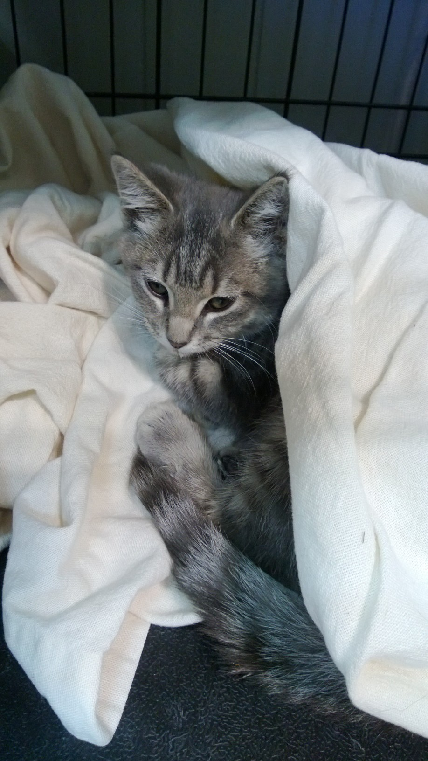



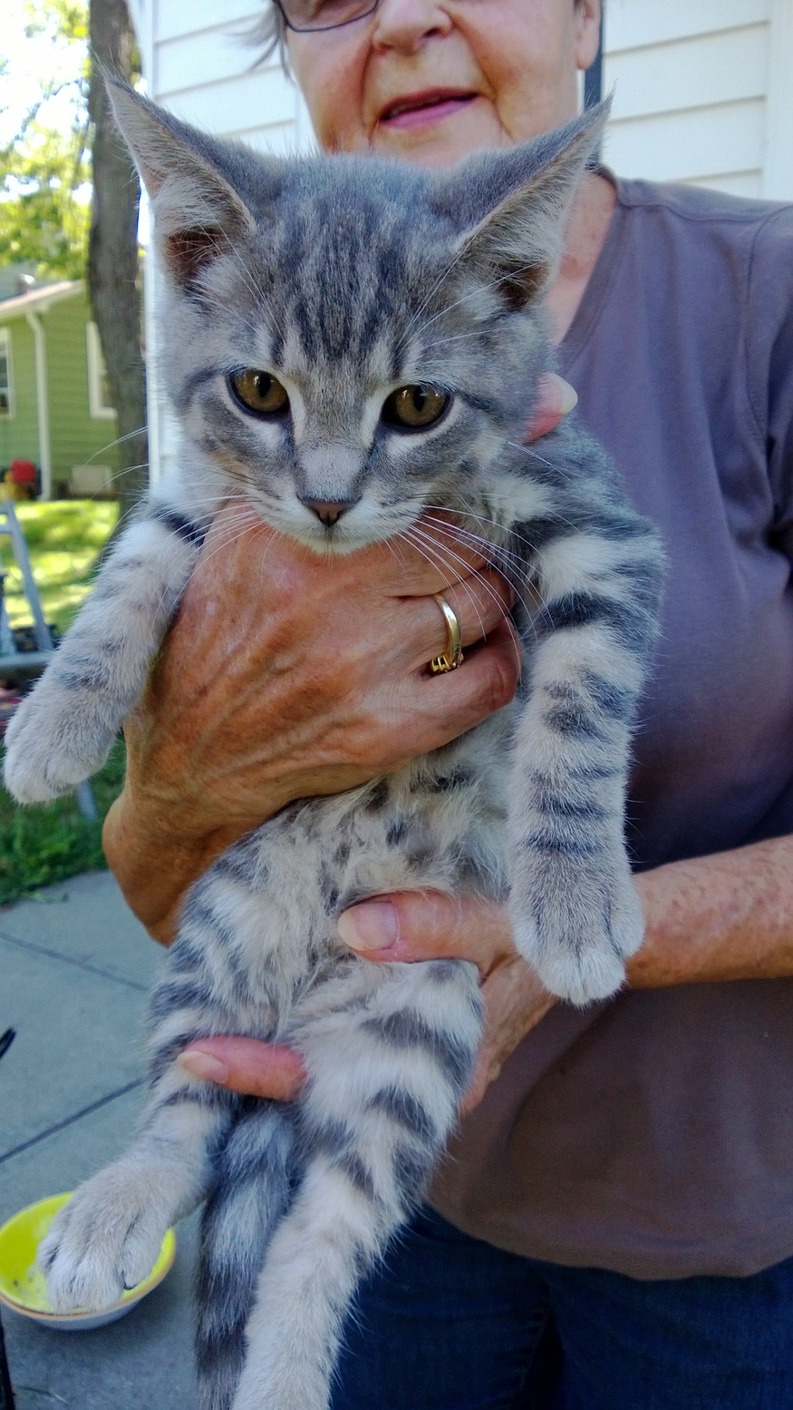

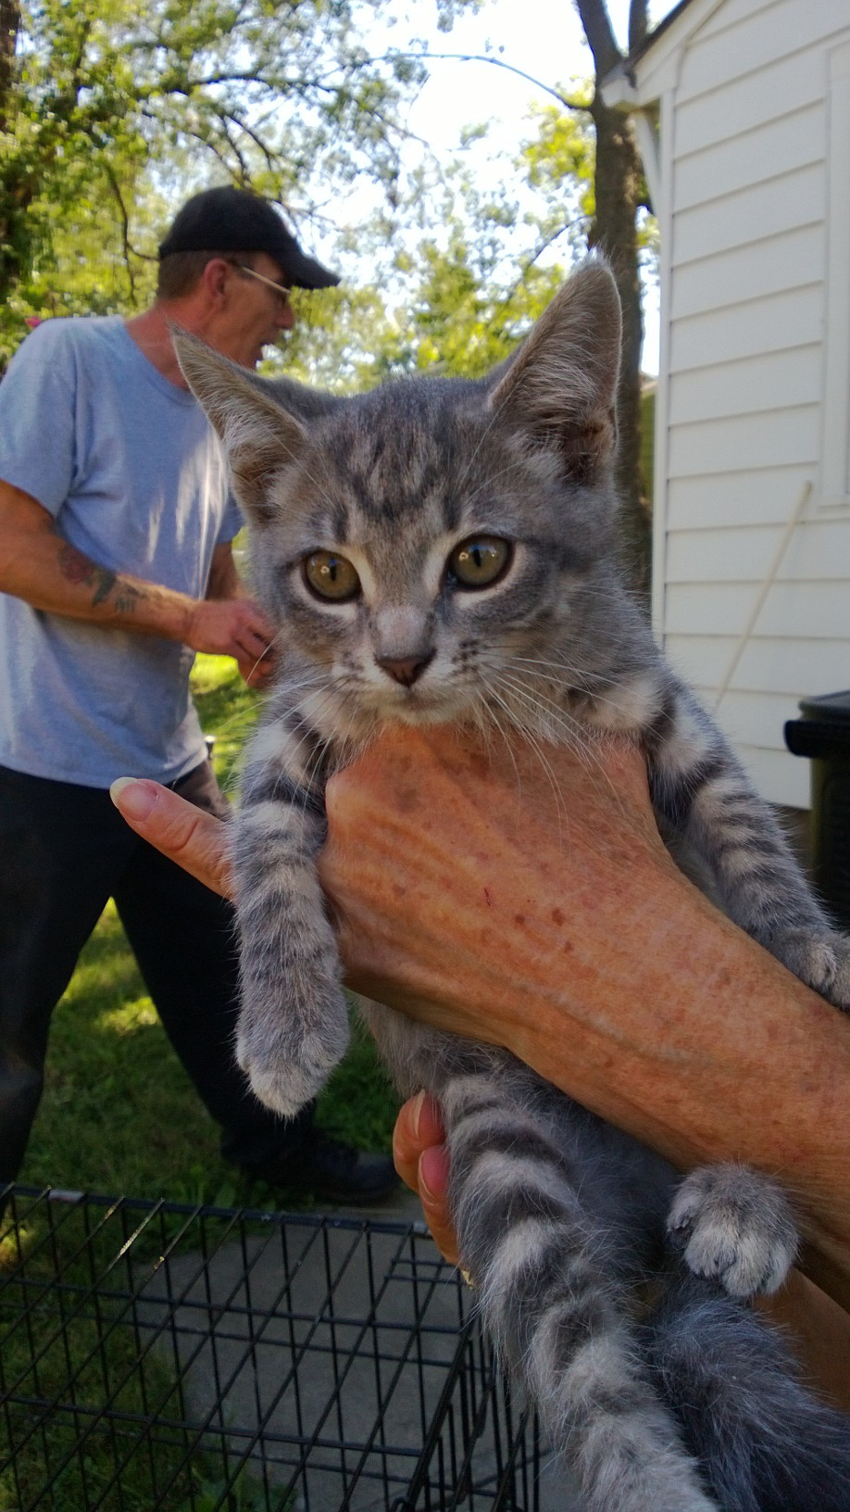

**These are 4 stray kittens that are being fostered by a residents of The Homes. Two are females and two are males. If you would like to adopt one or more please call Shirley Elmore 913-621-4628 or Annie Jude Bothwell 816-726-2260.**

9. What event cost $20 to attend?

|  |  |
| --- | --- |
| Quindaro Homes Federal Credit Union  As of August 31, 2013 | NEEDED |
| Assets: |  |
| LOANS | 523,295.38 |
| ALLOWANCE FOR LOAN LOSSES | - 13,292.90 |
| SECURITY BANK | 198,092.98 |
| CHANGE FUND | 200.00 |
| COMMUNITY AMERICA CU – SAVINGS | 85.88 |
| COMMUNITY AMERICA CU – CD | 105,448.85 |
| BANK MIDWEST | 54,275.92 |
| KCCU MEMBERSHIP SHARES | 11,428.85 |
| KCCU CASH MANAGEMENT | 1,456.57 |
| CREDIT UNION 1 SAVINGS | 26.28 |
| INDUSTRIAL STATE BANK | 84,813.63 |
| INTERSTATE FEDERAL SAVINGS & LOAN | 1,553.30 |
| INTERSTATE FEDERAL SAVINGS & LOAN | 100,000.00 |
| M & I BANK | 100,200.94 |
| COMMERICAL STATE BANK OF BONNER SPRINGS | 100,000.00 |
| PREPAID INSURANCE | 2,474.19 |
| FURNITURE & EQUIPMENT | 1,759.15 |
| NCUSIF | 9,839.09 |
|  |  |
| **TOTAL ASSETS** | **1,281,658.11** |
|  |  |
| Liabilities: |  |
| ACCOUNTS PAYABLE | 0.00 |
| AUDIT FEE - PAYABLE | 924.96 |
| NCUSIF PREMIUM PAYABLE | 801.85 |
| FEDERAL & KANSAS TAXES DUE | 110.00 |
| SHARED DIVIDENDS PAYABLE | 429.28 |
| MEMBER SHARES | 1,026,051.55 |
| REGULAR RESERVES | 31,510.21 |
| RESERVE FOR CONTINGENCIES | 26,500.00 |
| UNDIVIDED EARNINGS | 193,404.01 |
| NET INCOME | 1,926.25 |
|  |  |
| **TOTAL LIABILITIES** | **1,281,658.11** |

FOR SALE

Stackable Washer / Electric Dryer, $550, Al 913-428-6897

Dehumidifier, Like New, Original Cost $160, Sale Price $79, 913-371-4976

**STICKS AND LIMBS**

**Place sticks and limbs to the curb in manageable piles**

AM Mechanical Services

is offering air conditioning tune ups for $70

913-371-5885

Neighborhood Resource Center movedto their new location at 4953 State Ave. Eight UG divisions will be located together , including the KCKPD Community Policing Unit, to continue to provide a central location for neighborhood groups, businesses and residents to conduct business. The official opening of the new location is expected during the first week of June 2013.

**Spring Inspections**

Spring inspections are completed. If you received notice of what needs repaired or painted around your unit, you have 30 days to complete it. Railings around your porch must be painted white, black or grey. All exterior doors must be painted white, black or grey. All other colors must be approved by the board. The office supplies black and white paint.

Quindaro Homes Federal Credit Union will charge for credit reports.

Credit report for 1 person $20

Joint credit report (2 people*) $30 *You must be legally married*

6. What does the H stand for in the Halloween acronym?

**OPEN HOUSE**

**OCTOBER 5, NOON-2PM**

3116 N 9TH 830 ROSWELL 789 MANORCREST

|  |  |  |  |
| --- | --- | --- | --- |
| ONE BEDROOM | Owner | Phone | Price |
|  |  |  |  |
| TWO BEDROOM UP | Owner | Phone |  |
| 743 Manorcrest | QHFCU | 913.321.2471 | $4000 |
| 839 Manorcrest (No C/A, Stove, Fridge, W/D) | Jackson | 816.803.9914 | $9,255 OBO |
| 855 Manorcrest (C/A, Appliances, Dryer) | Ramos | 913.998.5248 | $8,000 |
| 3010 N Allis (C/A, Stove, Fridge) | Vazquez | 913.220.6918 | $10,000 |
| 3116 N 9th (C/A) | West | 913.999.2517 | $10,000 |
| 3151 N 9th (C/A, Stove, Fridge, W/D) | Reynolds | 913.991.1385 | $ 9,500 |
| TWO BEDROOM DOWN | Owner | Phone |  |
| 783 Manorcrest (C/A) | Deal | 913.707.2669 | $10,000 |
| 789 Manorcrest (C/A, Stove, Fridge, Jacuzzi) | Hudson | 816.898.5524 | $12,000 |
| 954 Manorcrest (C/A, Basement) | Ramos | 913.621.4532 | $13,000 |
| 841 Roswell | Gregg | 913.371.5673 | $10,233 |
| 1 Summitcrest (C/A, Stove, Shed) | Robleado | 913.488.5563 | $12,000 |
| 26 Viewcrest | Shields | 316.992.2115 | Contact S/H |
| THREE BEDROOM | Owner | Phone |  |
| 788 Manorcrest (C/A, Appliances negotiable) | O’Brien | 913.620.8521 | $12,500 |
| 822 Roswell (C/A, Appt Only) | Gallegos | 913.638.0521 | $14,500 |
| 827 Roswell (No C/A, WD) | Bolton | 913.396.3919 | $15,000 |
| 830 Roswell (C/A) | Llamas | 913.200.5322 | $10,500 |
| 44 Viewcrest (C/A, Deck, Appt Only) | Meraz | 913.991.8131 | $13,000 |
| 58 Viewcrest (C/A, Appliances, Shed) | Hackney | 913.271.5769 | $13,000 |
| DOUBLE UNIT | Owner | Phone |  |
| 84 / 86 Viewcrest, 2/2 Bedrm (C/A, Shed) | Eberhardt | 913.281.5847 | $17,000 REDUCED |

SPECIFICATIONS FOR PET OWNERSHIP IN THE HOMES, INC.

* Pets are to be penned, on a tie out or leash at all times they are outdoors.
* Dogs at large (not on leash, a tie out or in fenced area) are handled through Animal Control. Complainant should leave name and phone number, telling the dispatcher they want to file a complaint against the dog’s owner. Pets should not be tied near street-side sidewalks. These sidewalks are for public pedestrian use and are not to be obstructed.
* Residents are allowed no more than two (2) dogs or five (5) cats per unit. Any combination of up to five (5) pets is allowed as long as no more than two (2) are dogs.
* No excessive barking between the hours of 11 p.m. and 8 a.m.
* Excessive dog barking is not handled through Animal Control. Complaints should be referred to Mr. Greg Carr, Dispute Resolution, 913-573-5225. Complainant should leave their name, phone number and the address of the barking dog with Mr. Carr. Mr. Carr will contact the dog’s owner. The complainant remains anonymous.
* Pets required by city ordinance should be licensed and vaccinated for rabies yearly.
* Injured and stray-confined animals are handled through Animal Control. Complainant should follow up with Animal Control within 2 hours of first call.
* Defecation should be removed from the yard on a regular basis. If the stockholder is unable to do this work for any reason, there are services listed under pets in the yellow pages who do this work for a nominal fee.
* If The Homes has to remove excessive pet waste from a stockholder’s yard, there will be a $50.00 charge for each occurrence. Flagrant violations of these specifications can result in eviction under the nuisance clause of The Homes, Inc. Rules and Regulations.

THE HOMES UNITS FOR SALE

|  |  |  |  |  |  |  |
| --- | --- | --- | --- | --- | --- | --- |
| October 2013 | | | | | | |
| Sunday | Monday | Tuesday  1  NEIGHBORHOOD WATCH MEETING  6:30 PM | Wednesday  2 | Thursday  3 | Friday  4 | Saturday  5 |
| 6 | 7 | 8 | 9 | 10 | 11 | 12 |
| 13 | 14  CREDIT UNION CLOSED –COLUMBUS DAY | 15 | 16  CREDIT UNION BOARD MEETING 4:30PM | 17 | 18 | 19 |
| 20 | 21  THE HOMES BOARD MEETING 6:30PM | 22 | 23 | 24 | 25 | 26  THE HOMES HALLOWEEN PARTY 5-7PM |
| 27 | 28 | 29 | 30 | 31 |  |  |

NEWSLETTER INFORMATION: This newsletter is intended to inform and notify in an unbiased form. It is published in cooperation with The Homes, Inc., The Quindaro Homes Neighborhood Watch, The Quindaro Homes Federal Credit Union, and the stockholders of The Homes, Inc. No discrimination against any person or group is intended or tolerated. If a stockholder would like to submit material for the Newsletter, please submit to the office in writing no later than the 20th of the month. Newsletter Editors, Elizabeth Bothwell and Debbie Walters

10. Can you flush flushable wipes?

**Northeast Kansas Scottish Rite**

Rod and Custom get together

“Rodders for Children’s Ritecare”

Northeast Kansas Masonic Center

5201 W. 75th St., Prairie Village, KS 66208

913-831-7267

Saturday, October 5, 2013

Registration @ 9:00 am, Event 10-2 pm, Awards Ceremony @ 1:00 pm

Come join us for a day of fun!

Shrine clowns, and face painting!

Food & Drink

Enter your car or motorcycle for $20.00

**OCTOBER TRIVIA & FUN**

Halloween Facts

1. In case you were wondering whether a pumpkin is a fruit or a vegetable, the answer is a fruit.
2. Alaska grows pumpkins. Antarctica is the only continent that does not, because it cannot, grow these fruits.
3. The word “witch” comes from the Old English wicce, meaning “wise woman.” In fact, wiccan were highly respected people at one time. According to popular belief, witches held one of their two main meetings, or sabbats, on Halloween night.
4. Halloween originated in Ireland over 2,000 years ago Ireland is typically believed to be the birthplace of Halloween. According to Irish legend, Jack O’Lanterns are named after a stingy man named Jack who, because he tricked the devil several times, was forbidden entrance into both heaven and hell. He was condemned to wander the Earth, waving his lantern to lead people away from their paths.
5. Jack-o’-lanterns in the United States started from Irish immigrants who had previously been using turnips
6. According to tradition, if a person wears his or her clothes inside out and then walks backwards on Halloween, he or she will see a witch at midnight.

# Spirit Jugs Milk Jug Ghost Halloween Decoration

**Total Time** 1 hour

Stationed on a walkway or porch, these homemade lanterns

will extend a ghostly greeting your holiday visitors.

What you'll need:

Clean plastic gallon milk jugs

Black permanent marker

Craft knife

String of 50 clear low-wattage holiday lights

How to make it:

Draw ghost eyes and mouths on the jugs. **Tip:** Leave the caps on while you do

so the jugs don't dent. Use the craft knife to cut a half-dollar-size hole in the

of each jug (a parent's job). Arrange the ghosts near each other and string the

lights between them, stuffing several bulbs into each of the jugs.

Hot Dog Mummies



**Ingredients:**

1 package hot dogs

1 can (8 oz.) refrigerated crescent dough

Ketchup and mustard

**Directions:**

Preheat the oven to 375°F and line a sheet pan with parchment paper or a silicone baking sheet. Roll out your dough sheet and pinch any seams together. Cut vertical strips of dough evenly, about 1/2-inch thick. Pat hot dogs dry with paper towels. Wrap 1 strip of dough around each hot dog so that it looks like a mummy. Press the ends of the dough together firmly at the ends to secure. Place wrapped hot dogs 2-inches apart on baking and bake for 15-20 minutes or until golden brown.