C:\Users\The Homes\AppData\Local\Microsoft\Windows\Temporary Internet Files\Content.IE5\BURJVHXS\MC900445534[1].wmf

THE HOMES, INC January 2013

NEWSLETTER

THE HOMES, INC ∙660 MANORCREST, KANSAS CITY, KS 66101 ∙913-321-2471∙www.thehomesinc.com

TAG ENFORCEMENT

IF YOU SEE A VEHICLE THAT IS NOT STREET LEGAL OR HAS IMPROPER TAGS CALL OFFICER MARK SNELSON AT 913-573-8056

**ICE MELT**

YOU CAN BUY A BAG OF ICE MELT FROM THE OFFICE FOR $3.00

VEHICLE REPAIRS IN THE HOMES IS PROHIBITED.

IF YOU SEE SOMEONE MAKING REPAIRS TO THEIR VEHICLE CALL THE POLICE 913-596-3000

2012 Real Estate Taxes

**Pro rata portion of 2012 real estate taxes:**

**Single unit: $294.41**

**Double-unit: $588.82**

**Be Kind!**

If it snows don't park in a spot you normally wouldn't. If a neighbor takes the time to shovel out the space they normally park at, then respect their hard work and don't park there.

Inside This Issue

Neighborhood Watch 2

Board Meeting Minutes 3-5

Prepare your vehicle for winter 6

Events 8

Tips for shoveling snow 10

Hints about living in The Homes 12

Public Service Announcements 13-14

Q.H.F.C.U 15

Units for Sale 16

Calendar 17

Fun & Trivia 18

**IMPORTANT TELEPHONE NUMBERS**

THE HOMES INC 913-321-2471

AFTER HOURS MAINTENANCE 913-948-2211

Q.H.F. CREDIT UNION 913-342-3421

KCK POLICE DEPARTMENT 913-596-3000

KCK ANIMAL CONTROL 913-321-1445

POTHOLES 913-573-8307

CITY QUESTIONS & COMPLAINTS 311

STREET LIGHTS/POWERLINES 913-573-9522

BPU 913-573-9000

KS GAS SERVICE 1-800-794-4780

THE HOMES

BOARD MEETING

January 21, 6pm

IN THE CLUBROOM

Stockholders are welcome!

FOLLOW US ON ...  AND 

**NEIGHBORHOOD WATCH NEWS**

**Meeting at the clubroom on Tuesday, January 8th, 6:30pm**

**JOIN NEIGHBORHOOD WATCH**

-Crime loves darkness, hates light.  Keep your porch lights on at night.  The Neighborhood Watch can install a dawn-to-dusk attachment on to your porch light for $11.00 that will turn the light on at dusk and turn it off in the morning.  BPU estimates a 75 watt bulb in a dawn-to-dusk fixture costs about 15 cents a month in electricity.

-If you see anything out of the ordinary (strangers roaming the neighborhood, peering into car windows, etc.) call the police.  If a stranger knocks on your door with a sob story about their wife having the debit card, etc. politely refuse them, carefully note their description and call 911.  It is against the law to panhandle.  Report the description to the office so the maintenance men can be on the lookout as well.

**STREET CRIME IS ON THE INCREASE. BELOW ARE SOME EASY TIPS TO FOLLOW TO KEEP SAFE.**

**1. STAY ALERT**When walking down the street, be aware of who is behind you and who is in front of you.

**2. TRY NOT TO USE YOUR MOBILE PHONE IN THE STREET**Mobile thefts have risen dramatically. Apart from advertising the fact that you have a mobile phone which can attract a potential attacker, having a conversation prevents you from being aware of what's going on around you. There are other disadvantages too. If you're busy chatting on the phone and then you are attacked, this can prevent you from phoning the police or someone else who could come to your rescue.

**3. WALK IN THE CENTER OF THE PAVEMENT**

Self defense experts recommend walking in the middle of the pavement - and not too close to doorways. This means you avoid the path of strange people lurking - and avoid any danger from passing cars. Also, try to walk close to crowds and well-lit areas.

**4. SHOUT FIRE, NOT HELP**If you are being attacked, self defense experts recommend shouting 'fire' not 'help'. This is because hearing the word 'fire' is guaranteed to attract more people's attention for the simple reason that they think it could affect them too.

**5. ORGANISE A BUDDY SYSTEM**It sounds obvious, but just letting someone know what time you are expected home can be crucial to your safety. This means if you are late - and friends or family know where you are - they can raise the alarm. Self defense experts recommend putting in place a 'buddy' system where you ring or text a friend or partner to let them know if you are running late and what time you are expected home.

**5. PURCHASE A PERSONAL ALARM**This device is very handy in keeping you save. When triggered it delivers a piercing alarm that can thwart off attackers. They come in convenient sizes and can be clipped to a belt or purse, worn around the neck or on a keychain. Different designs are pictured below. You can buy a personal alarm online or at Wal Mart, Radio Shack, Lowes and Home Depot.

2. What is the cost to have your unit appraised?

[](http://www.homedepot.com/h_d1/N-5yc1v/R-100657692/h_d2/ProductDisplay?catalogId=10053&langId=-1&keyword=personal+alarm&storeId=10051)



[](http://www.homedepot.com/h_d1/N-5yc1v/R-203485500/h_d2/ProductDisplay?catalogId=10053&langId=-1&keyword=personal+alarm&storeId=10051)

SPECIFICATIONS FOR PET OWNERSHIP IN THE HOMES, INC.

* Pets are to be penned, on a tie out or leash at all times they are outdoors.
* Dogs at large (not on leash, a tie out or in fenced area) are handled through Animal Control. Complainant should leave name and phone number, telling the dispatcher they want to file a complaint against the dog’s owner. Pets should not be tied near street-side sidewalks. These sidewalks are for public pedestrian use and are not to be obstructed.
* Residents are allowed no more than two (2) dogs or five (5) cats per unit. Any combination of up to five (5) pets is allowed as long as no more than two (2) are dogs.
* No excessive barking between the hours of 11 p.m. and 8 a.m.
* Excessive dog barking is not handled through Animal Control. Complaints should be referred to Mr. Greg Carr, Dispute Resolution, 913-573-5225. Complainant should leave their name, phone number and the address of the barking dog with Mr. Carr. Mr. Carr will contact the dog’s owner. The complainant remains anonymous.
* Pets required by city ordinance should be licensed and vaccinated for rabies yearly.
* Injured and stray-confined animals are handled through Animal Control. Complainant should follow up with Animal Control within 2 hours of first call.
* Defecation should be removed from the yard on a regular basis. If the stockholder is unable to do this work for any reason, there are services listed under pets in the yellow pages who do this work for a nominal fee.
* If The Homes has to remove excessive pet waste from a stockholder’s yard, there will be a $50.00 charge for each occurrence. Flagrant violations of these specifications can result in eviction under the nuisance clause of The Homes, Inc. Rules and Regulations.

**6. What cooling center is located at 701 N. 7th Street?**

Zorro &

Sophie (brother and sister)

MINUTES OF THE BOARD OF DIRECTORS

THE HOMES, INC.

December 17, 2012

President Harold Watson called the regular monthly meeting of the Board of Directors of The Homes, Inc. to order at 6:00 p.m. on December 17, 2012.

Present were: Harold Watson, Karen Anver, Frank Moss and Kayla Ross, Board Members; Elizabeth Bothwell, Manager; Greg Goheen, Attorney; and Karen Brokesh, Transcriber. Elaine Hines was absent.

Seven stockholders attended the meeting.

President Watson welcomed the stockholders to the meeting and announced that, as provided by the By-Laws of the corporation, only stockholders of record are entitled to attend the board meeting. President Watson also asked all stockholders in attendance to hold their questions and comments until after the finish of regular business at which time anyone who wishes to speak will be allowed to make a statement.

President Watson reminded the stockholders to state their name and address so that the minutes can accurately reflect all comments made during the open session. Stockholders were asked to hold their comments until executive session or to speak with the manager one-on-one if they did not want their comments reflected in open session.

Stockholders are reminded that if they have a problem with their unit, to please report it to the office during regular business hours.

It was announced that the work order report for November, 2012 has been posted.

Minutes of the regular meeting of November 19, 2012 and the November 19, 2012 Executive Session had previously been distributed to all board members. Kayla Ross moved to approve the minutes as written. Seconded by Frank Moss. Carried unanimously.

Treasurer Anver reported that the financial statements have been reviewed and were found to be in good order. The income statement and balance sheet were posted for the duration of the meeting. Frank Moss moved to accept the financial report as presented. Seconded by Kayla Ross. Carried unanimously.

Stockholder change requests approved by the manager are as follows:

876 Manorcrest: Install satellite dish – Michael Price. Work will be done by dish company.

85 Viewcrest: Install satellite dish – David Palacios. Work will be done by Dish Network.

There were no stockholder change requests for board consideration.

Kayla Ross read the stock transfer approvals as follows:

|  |  |  |
| --- | --- | --- |
| **ADDRESS** | **TRANSFER FROM** | **TRANSFER TO** |
| 14 Summitcrest | Andrew Bradley Weichelt and Sarah Frances Weichelt | Fernando Gardea and Blanca Gardea |
| 819 Roswell | Mirtha Herrera, Maria Hernandez and Pedro Herrera | Mirtha Herrera and Pedro Herrera |

After being informed that the stock transfers were in order, it was moved by Kayla Ross and seconded by Frank Moss the Corporation waive its option to purchase the shares of stock and approve transfer of same. Carried unanimously. The manager was reminded that all original signed stock certificates must be stored with the credit union if the stockholder has an outstanding loan.

Kathryn Kisthardt of Google Fiber was present at the invitation of the board to provide a presentation on the internet and cable services coming to the area and to answer questions. Ms. Kisthardt is not sure when the service will be available in The Homes. Ms. Kisthardt then left the meeting.

*Announcements:*

Terry Zeigler with the Kansas City Kansas Police Department will be at the January, 2013 Neighborhood Watch meeting. The Unified Government holiday tree decorated by Neighborhood Watch received third place. Karen Anver and Tammy Eklund were thanked for their help decorating the tree.

The board thanked everyone who attended and participated in the annual Christmas Party for the children. Gifts were given to over 80 children. Oots Lawn Care Service also donated a photo booth which was much enjoyed by everyone.

Stockholders were reminded that they are responsible for keeping their steps and sidewalks clean of ice and snow this winter. Stockholders who are unable to do this themselves may contact the office for recommendations on persons to contact.

The winners for the best holiday decorations in the neighborhood were: 942 Manorcrest, 12 Viewcrest, 4 Summitcrest, 828 Roswell and 3157 N. Allis. The winners will each receive $20.00 gift cards to Wal Mart. The board thanked Rosetta Cantwell and Sherry McCool for their help as judges.

This month’s winner of the stockholder trivia was the stockholder at 828 Manorcrest who will receive $25.00 of next month’s maintenance fee.

*Old Business to be Discussed:*

The Finance Committee reported that the corporation had a good month. Year to date income continues to exceed expenses.

*New Business to be Discussed:*

Manager is looking into buying additional tables and chairs for use in the clubroom. Four tables can be purchased for $588.00 and thirty-six chairs will cost $565.00.

The Annual Meeting of the stockholders will be held on March 8, 2013 at 8:00 p.m. in the clubroom. The doors to the clubroom will open at 7:45 p.m. The board positions currently held by Harold Watson, Karen Anver and Elaine Hines will be up for re-election. The General Election for the three vacancies on the Board of Directors will be held from 7:30 a.m. through 7:30 p.m. on March 8, 2013. Only stockholders of record as of midnight February 15, 2013 will be eligible to vote in the election. Only one vote per share of stock is allowed even though there may be more than one stockholder listed on the share of stock.

The board asked for volunteers for Election Judges for the March 8, 2013 election. The Judges must be present from 7:30 a.m. until the final tally of the votes are counted at the end of the election and then reported at the Annual Meeting. Bill Bradford has agreed to serve on the committee. Evelyn Doorman and Jim Tavis will be contacted to see if they will volunteer to serve as Judges.

The letters and nomination forms for the upcoming annual meeting were distributed to the board. Kayla Ross moved that the nomination form be mailed no later than January 18, 2013. Seconded by Frank Moss. Carried unanimously. Frank Moss moved that February 8, 2013 be set as the deadline to return the nomination forms. Seconded by Kayla Ross. Carried unanimously. Karen Anver moved that the corporate books be closed and the annual meeting letter be mailed no later than February 15, 2013. Seconded by Frank Moss. Carried unanimously.

The board asked for volunteers for the Nomination Inspection Committee. The Committee sorts nominations and counts and delivers acceptance forms to all nominees. Persons interested should contact the office.

*Comments from Directors and Attorney:*

Harold Watson thanked the board and staff for all of their hard work this year.

*Comments from Stockholders:*

Beverly Waltrip, 25 Viewcrest, reported on problems she has been having with her neighbors as well as parking violations in The Homes. The police have not been responsive to her calls.

Jerry Demeyer, 4 Summitcrest, wished everyone a Merry Christmas.

Sherry McCool, 12 Summitcrest, commented on the increased number of beautifully decorated houses in the community this year.

Mary Jane Watson, 28 Summitcrest, commented on the amount of trash seen in the neighborhood.

No further business to come before the board the board adjourned into executive session.

______________________________

R. ELAINE HINES

SECRETARY

APPROVED:

____________________________

HAROLD WATSON

PRESIDENT

Transcribed by Karen Brokesh

9. What is the pro rata portion of the 2012 real estate taxes if you have a single unit?

**FOOD PANTRIES**

**This time of year can definitely stretch your wallet. If you or your family are in need please contact one of the agencies below. The usual requirements to receive food are - be a resident of Wyandotte County and have a photo id or proof of residency (utility bill or official mailing). Some of these pantries will help new mothers by providing diapers and baby food.**

**Argentine Food Kitchen**  
Cross Lines Annex, 646 Shawnee Ave., Kansas City, KS (Armourdale Area)  
Serves lunch Monday - Friday 11:30 - 1:00. No Charge and no qualifications.

**Armourdale Baptist Church**  
700 S. Mill Street, Kansas City, KS 66105, 913-371-6476. Open Monday only 10:00 a.m. -12:00

**Bethel-Riverview Coordination and Development**947 Osage, Kansas City, KS 66105, (913) 321-7418

**Bethel Seven Day Adventist Church**6910 Riverveiw Ave, Kansas City, KS 66102, 913-788-7250 ex. 3. Pantry open Wed 5:30 - 7:00 p.m. Must call Tuesday to make an appointment.

**Better Living Center**7217 Troost Ave, Kansas City, KS 64131, (816) 523-1115

**Catholic Charities of Wyandotte County**  
2220 Central Ave., Kansas City, KS 66102, 913-621-3445

**Catholic Community Services-Emergency Center**  
632 Tauromee, Kansas City, KS 66101, 913-621-3445

**Friends of Yates Inc.**  
1219 North 13th Street, Kansas City, KS 66102, (913) 321-1566

**Harvest America**

14th & Metropolitan, Kansas City, KS 66103, 913-281-2781

**Harvesters The Community Food Network**  
3801 Topping Ave, Kansas City, KS 64129, (816) 929-3000

**Lloyd Siebert Food Pantry/Share, Inc.**  
Central Avenue Center of Hope, 11 N 15th Street, Kansas City, Kansas 66102, 913.233.2511

**Metro Ave. UMC**  
3730 Metropolitan Ave., Kansas City, KS 66106, 913-831-4531, Tues & Thursday 9:00 -11:00

**Northeast Coordination and Development**950 Quindaro, Kansas City, KS 66101, (913) 371-0848

**Open Door Ministries**  
819 Armstrong Ave. Apt 8, Kansas City, KS, (913) 271-2670‎

**Salvation Army**  
500 N. 7th St., Kansas City, KS, (913) 321-6958

**HOLIDAY DECORATION CONTEST**

Thank you to all residents that participated in holiday decorations. You made our community more festive and appealing. Please remember to have your decorations removed by February 1st 2013.

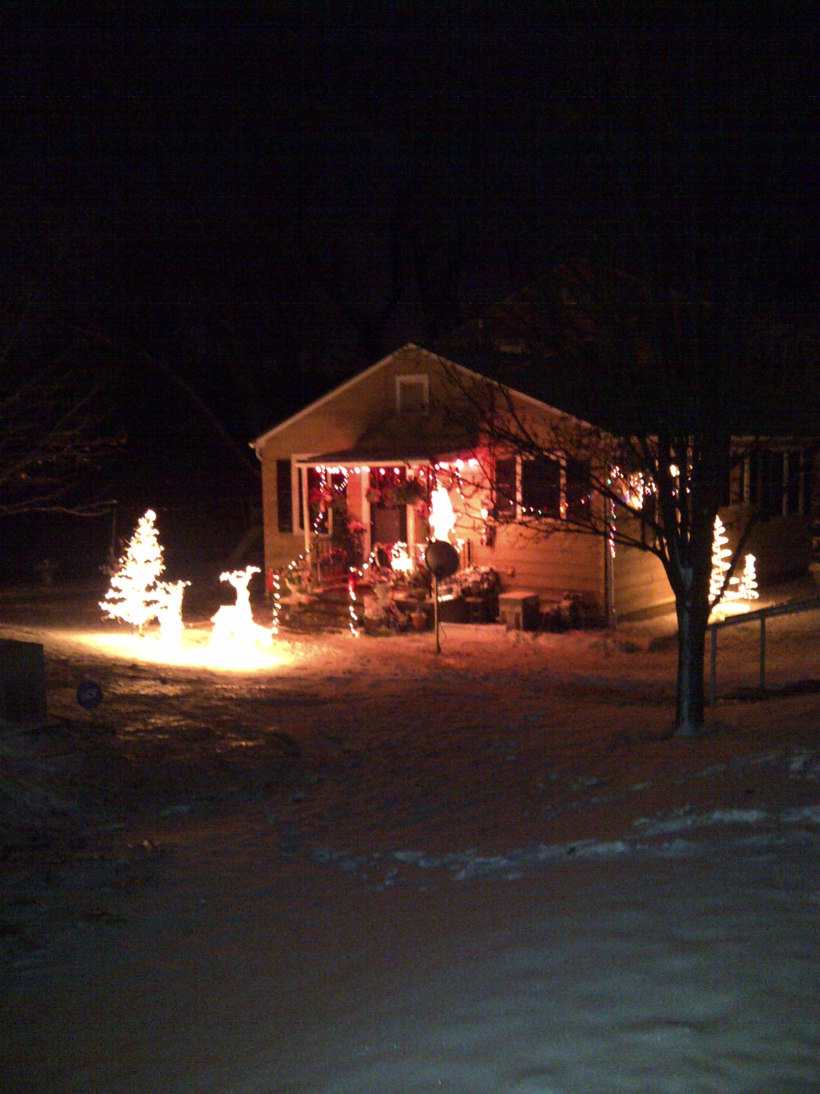

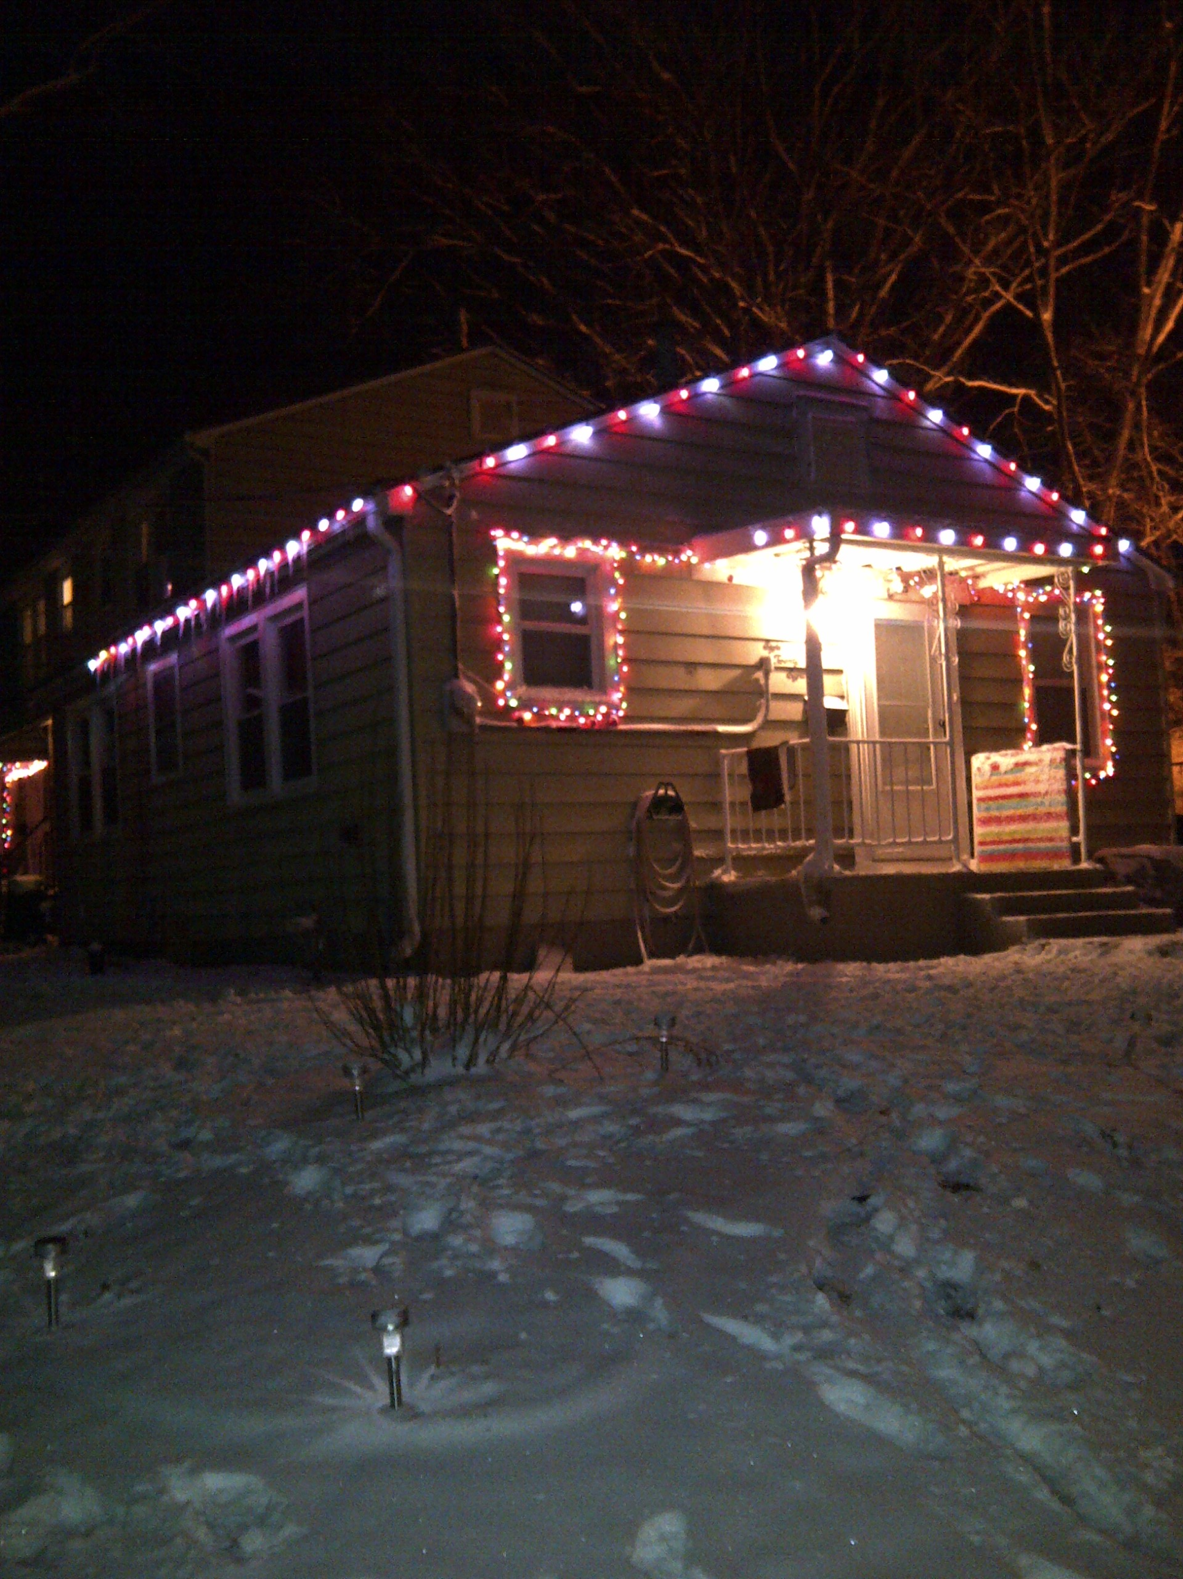

12 Viewcrest

828 Roswell

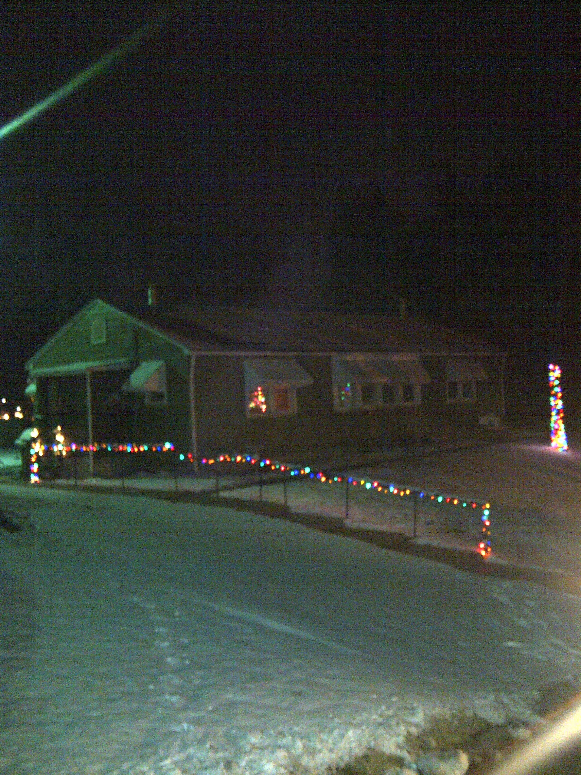

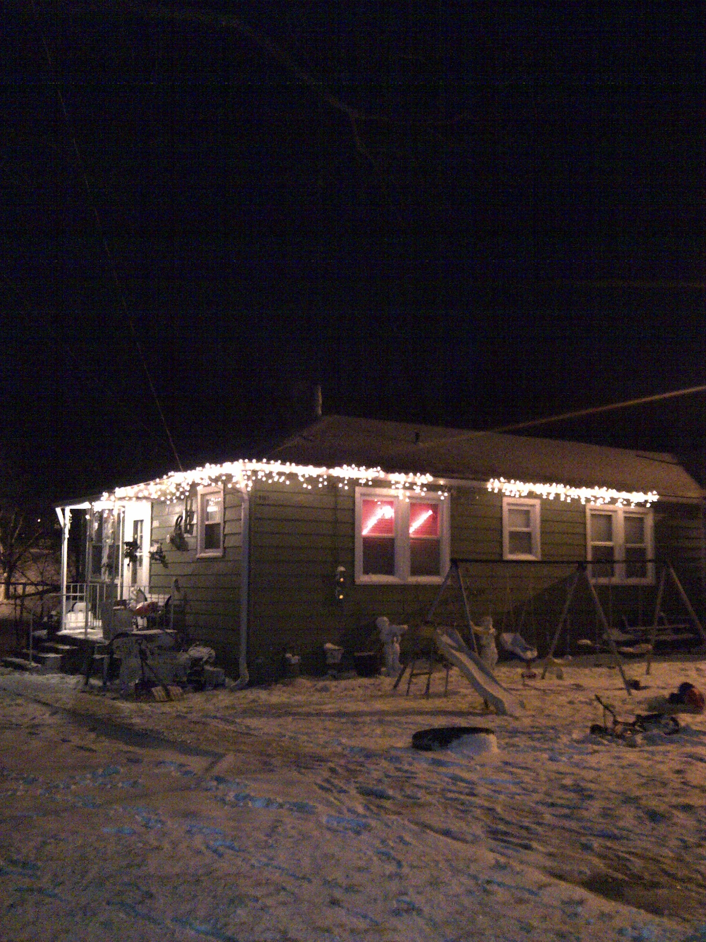

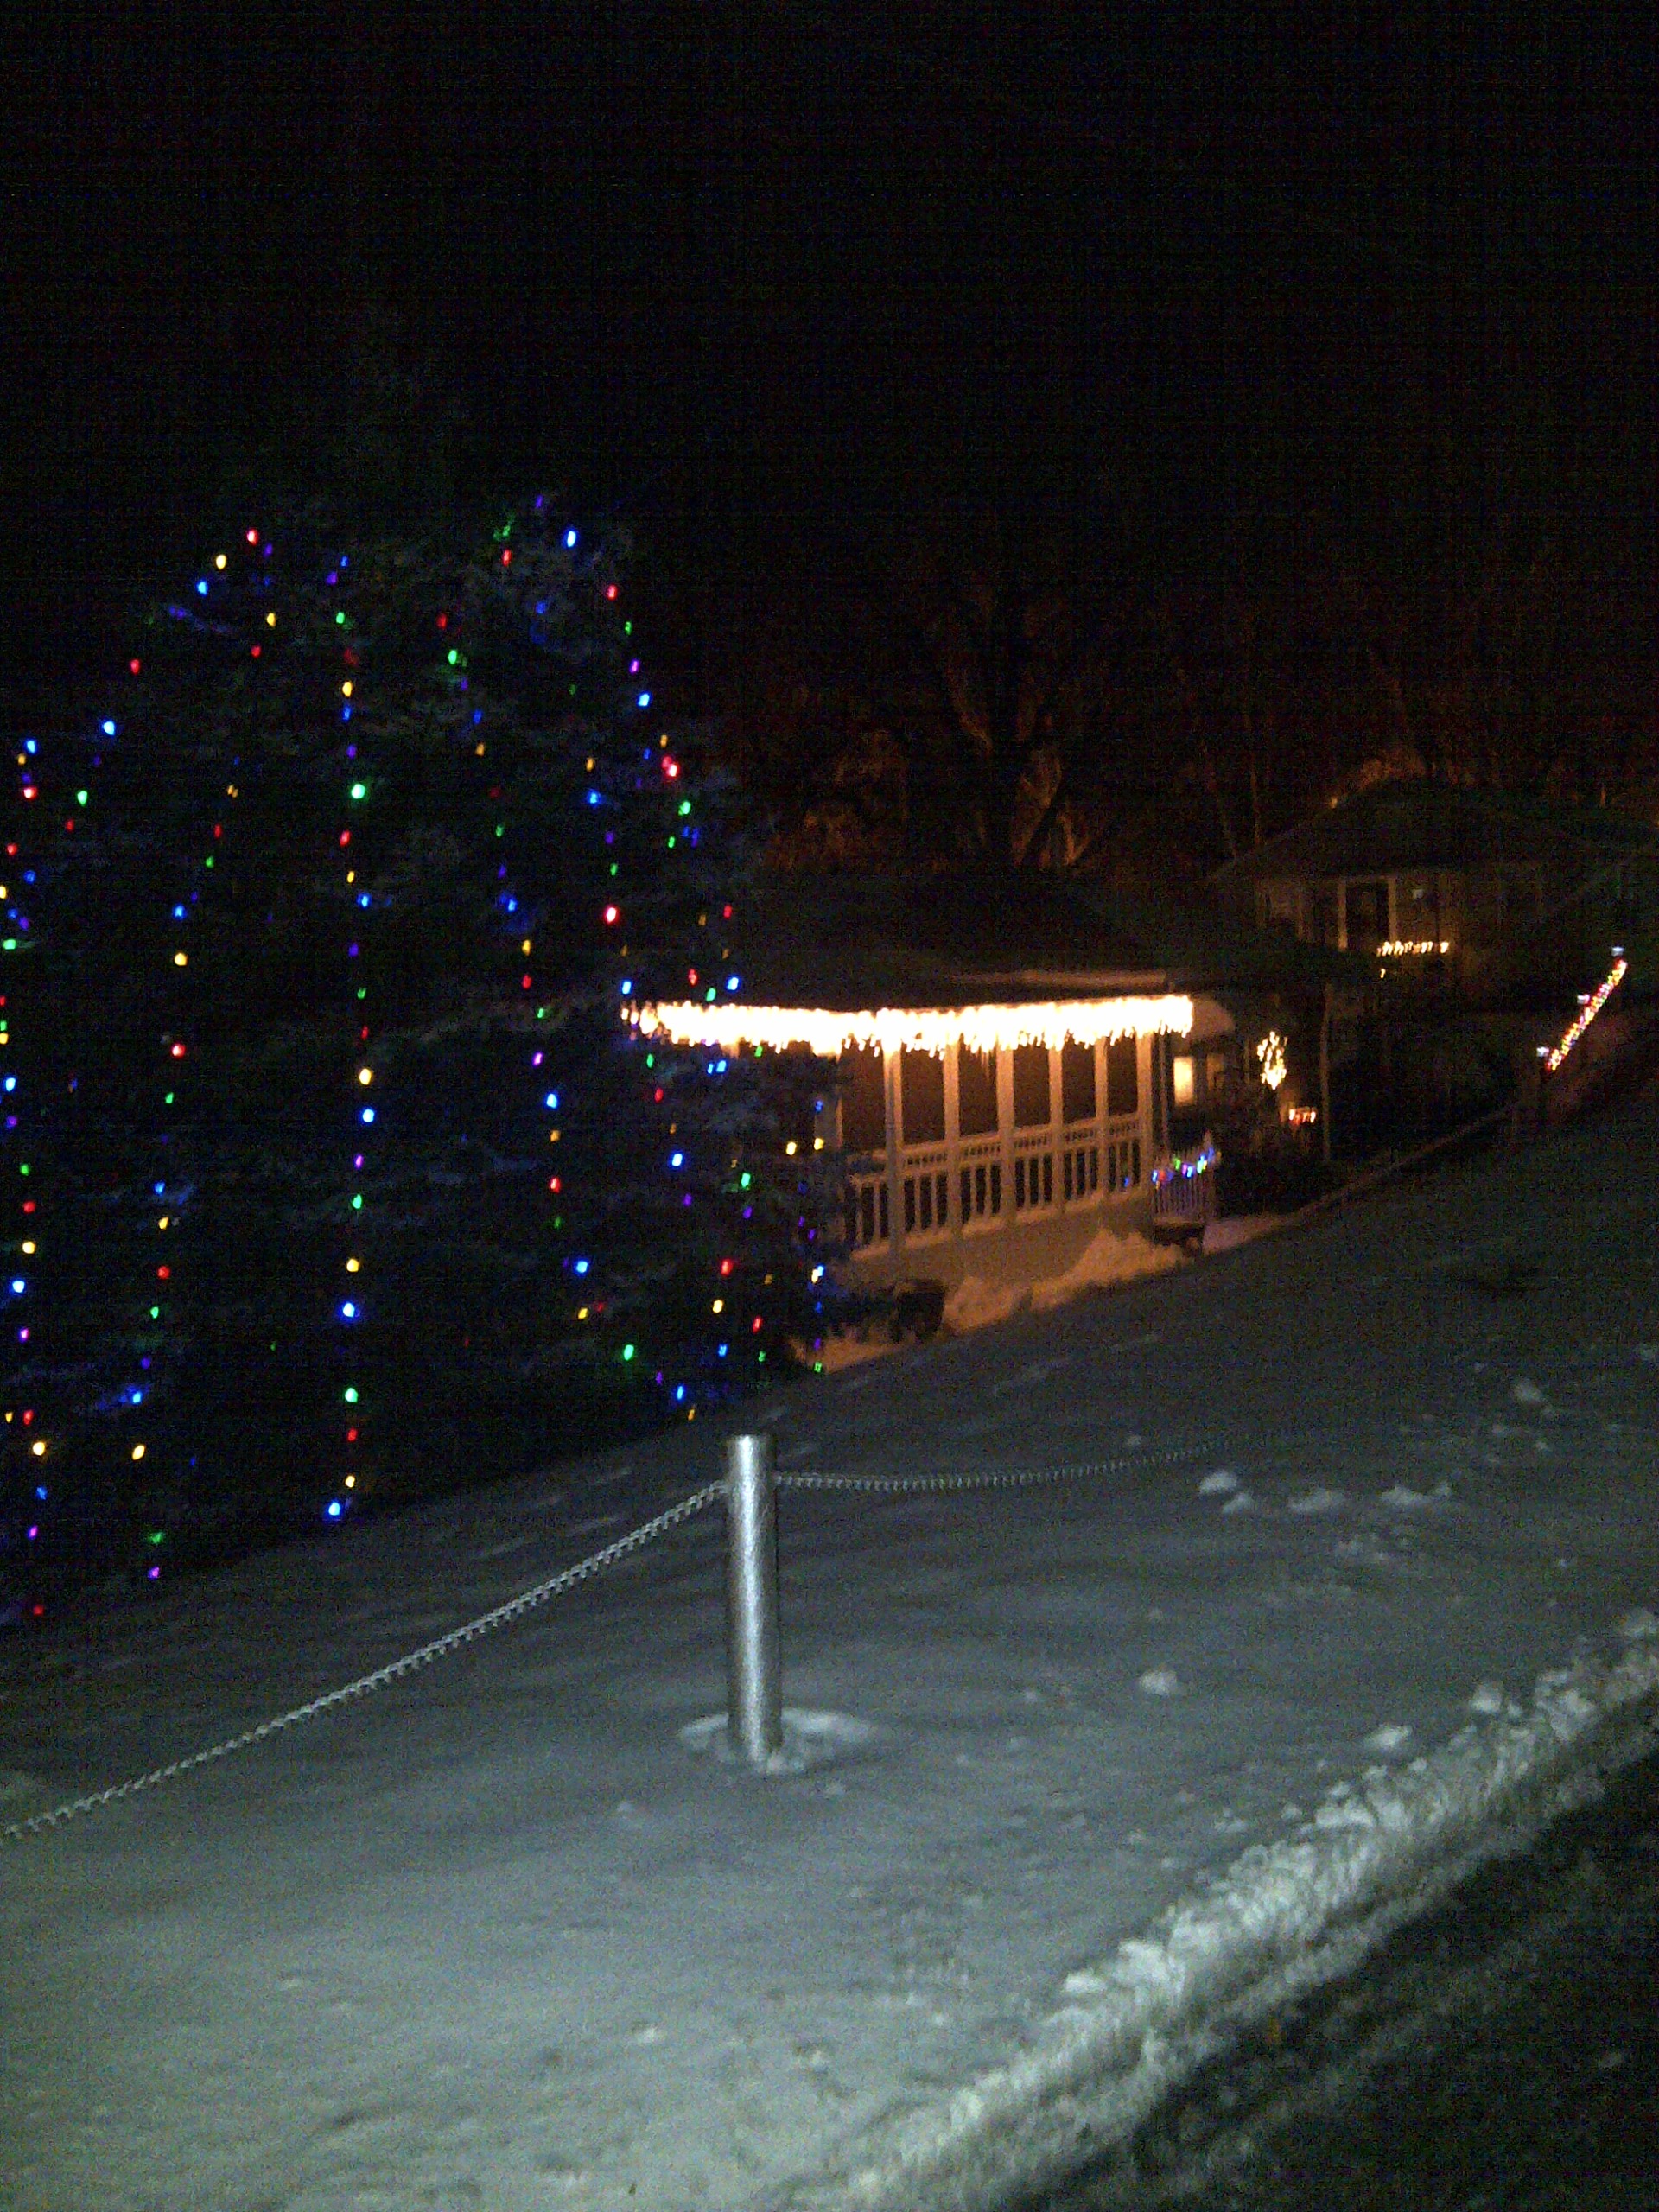

4 Summitcrest

942 Manorcrest

3157 N. Allis

**NEWSLETTER TRIVIA**

We want to encourage all residents to read the newsletter. You will find 10 questions within the newsletter. Write down your answers, along with your name and address. Bring the information to the office and drop it in the lock box. At the monthly board meeting we will randomly choose an answer sheet and if all the answers are correct, that resident will receive $25 off the next month’s maintenance. The following is the first question…

1. What kind of shoes were made for Lady Gray?

Now find the other nine questions and bring your answers to the office!

Employees and board members of the Homes and their family members are not eligible to participate.

**EVENTS AROUND TOWN**

**11/17/12 to 1/27/13 - Christmas at the Strawberry Hill Museum**

720 North 4th Street, Kansas City, KS 66101, 913-371-3264. [www.strawberryhillmuseum.org](http://www.strawberryhillmuseum.org)

The museum will open its doors to the Christmas season on November 17, 2012.

**Free Fitness Classes for Seniors & Young Adults**

Quindaro Family Health, Faith Lutheran Church, 530 Quindaro Blvd, 913-621-0100, ext 208

* Bend & Flex, strengthening & stretching exercises, 11-11:45 am, Tuesdays & Fridays
* Wu-Qiqigong, flowing form of meditation for healing, giving relief for pain & stress, 5-6pm , Thurs.

**Workforce Development at Kansas City Kansas Community College**, 7250 State Ave., KCK, 913-288-7659, A full complement of training solutions in order to meet your needs.

**Quindaro Boulevard Family Health Care:** 530 Quindaro Boulevard, KCK 66101. Phone: (913) 722-3100. [www.swbfhc.org](http://www.swbfhc.org), Se habla Español. Your Health is important to us! Family Health Care provides primary health care for the entire family. Services include care for pregnant women, children and adults (including chronic diseases such as HIV, HepC and diabetes). Family Health Care is a non– profit safety net clinic with services provided on a sliding scale for those who do not have insurance. Our goal is to improve your family’s health by providing comprehensive health care services. No patient is turned away for inability to pay. Call (913) 722-3100 for an appointment. Monday - Friday Social and legal services from 12:00pm to 6:00pm Monday - Thursday The medical clinic is open 3:00pm to 6:00pm

**New and Used Building Materials & Workshop:** Habitat for Humanity Restore, 4701 Deramus Ave. K.C, MO or 303 W. 79th St. K.C., MO, 816-231-6889. Hours are Monday – Friday, 10am – 6pm (Donations/purchase pick-up until 5pm); Saturday, 9am – 4pm (Donations/purchase pick-up until 3pm)

**Medicare Savings Program Application Assistance** is offered by appointment, over the phone, or in your home. Senior Health Insurance Counseling for Kansas (SHICK) is a free program offering older Kansans an opportunity to talk with trained, community volunteers and get answers to questions about Medicare and other insurance issues. Please call the SHICK Hotline at 1-800-860-5260 to speak to a volunteer. If you are a resident of Wyandotte or Leavenworth County, you can reach a local volunteer at 913-573-8531.

**ARE YOU TURNING 65 THIS YEAR? ARE YOU ALREADY RECEIVING MEDICARE BENEFITS? IS YOUR SOCIAL SECURITY INCOME LESS THAN $1361 PER MONTH**

**($1839 per month for a married couple)?**

Then…you need to apply for Extra Help from Medicare. Medicare, not you, may pay for your premiums, copays, and deductibles! For help by appointment in our office call the local SHICK office at the Wyandotte/Leavenworth Area Agency on Aging at 913-573-8531 or 1-888-661-1444. APPLY for extra help with the Social Sec. Administration online at www.social security.gov, or by phone at 1-800-772-1213.

**Live in Wyandotte County?** **Have a family?** Call CONNECTIONS, 913-321-9999. We can help you make the right connections to build a strong family. You want the best for your family — we’re here to help. If you are pregnant or care for a child under five years old, CONNECTIONS is for you. We can help you find answers to important questions for your family. CONNECTIONS is available for no cost, and we can visit you in your home. Call us to get connected to community resources today. Parenting Skills • Parent Health /Child Health • Independence Household Necessities/Housing Support • Job Advice

**Free Hair Cuts and Trims**

The Keeler Women’s Center, located at 2220 Central Avenue, is offering free haircuts and trims for women and men. Call and check on the 2nd and 4th Mondays to see if our volunteer, Donna McCarty, is coming. 913-906-8990.

**OUR ANNUAL CHRISTMAS PARTY WAS A LOT OF FUN. OVER 80 CHILDREN RECEIVED GIFTS. WE ENJOYED GOOD FOOD, CHRISTMAS CARROLING AND A LOT OF PICTURES.**

**Thank you to our vendors and contributors**

**McAnany, Van Cleave & Phillips, Rick Medill, Ed OMalley, Borland Construction, Jay’s Plumbing, Brotherhood Bank, Zephyr Awning, Adams & Beaubien, Patterson & Assoc., Oots Lawn Service, Jerry DeMeyer and Bob Anver.**

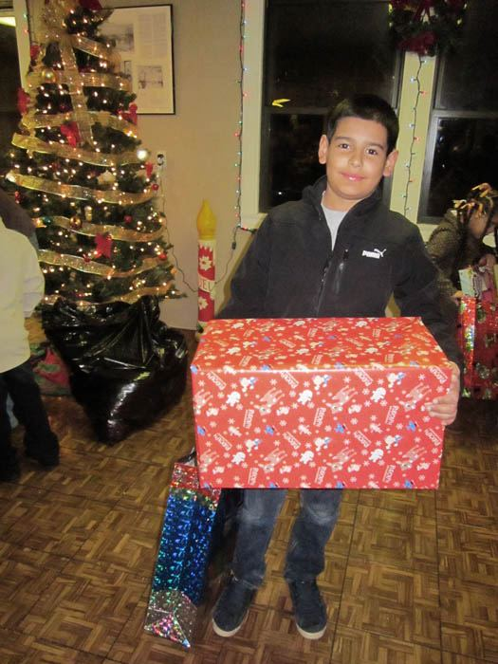 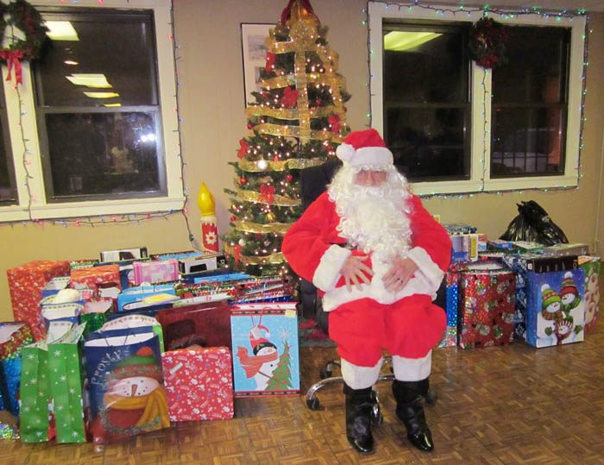 

THANK YOU

Throughout the year there are so many stockholders and friends that contribute to the Homes by helping at events, donating food, money and supplies, kind and encouraging words, giving helpful information, serving on a board or a committee and much more. I would like to thank you all. The Homes is a much better place because of you.

|  |  |  |
| --- | --- | --- |
| Beatrice Arce  Bob & Karen Anver  Arline Ayers  William Bradford  Tyretta Byers  Rosetta Cantwell  Sharon Carrazco and family  Jean Coffelt  Sherry Davis  Evelyn Dorman  Tammy Eklund  Donna Elliott  Shirley Elmore  Barbara Foxworthy  Sarah Franklin  Jena Garr | Gai Green  Jennifer Gregg  Ralph Heiden  DJ Henderson  Elaine Hines and Devra Harrison  Hudson, John  Melonie Jones  Sandra Pinela Madrid  Sherry McCool  Silvia Mclaughlin  Aaron Melendez  Said Melendez  Jennifer Morris  Frank and Julie Moss  Sharon Norris  Joni Olivarez | Loreana Prince  Pat Reid  Travis Renne  Dorothy Reynolds  Judy Reynolds  Kayla Ross  Lisa Ross  Charlie Sawyer and family  Deanna Schwartze  Carla Simpson  George Tucker  Harold and Mary Jane Watson  Rebecca Westpfahl  Bob Whittington  Jim & Linda Tavis  Robert Tavis |

To all those that are unnamed but appreciated

The Homes staff – Jerry DeMeyer, Merle Goldston, Dee Dee Johnson, Marvin Smith, Abe Sawyer, Debbie Walters and their families

Credit Union staff – Dee Hartner and Diane Simmons

My family – Todd, Dillon and Annie Jude Bothwell

3. When do holiday decorations have to be removed?

**Tips for shoveling snow**

Winter is here and that means the possibility of snow. For efficiency and safety follow these tips to shoveling snow.

1. Stretch first. Don't be in a hurry to get outside. Stretch thoroughly using the same sorts of moves that runners, mountain bikers and other athletes use. Stretch your hamstrings, stretch your back, and stretch your shoulders. Then dress in removable layers, grab your shovel and resist the urge to fly at the white stuff just to get the job done. Pace yourself. Start slowly and ramp up to speed.

2. Don't move snow twice. Before you even take your first scoop, decide where you're going to dump the snow. Drop the first shovelful farther away from where you are standing, then dump remaining snow closer and closer to where you are. That way, the last scoops that you shovel are moved the shortest distance. Don't block access to snow that needs to be removed by piling it up in a way that will force you to move it twice.

3. Move snow the shortest distance possible. Consider that everything from a driveway to a patio to a walkway is really a rectangle, and rectangles have a center point. Move the snow from the center of the rectangle to the nearest edge.

4. Clear cars first. Brush snow off cars then clear around the cars.

5. Do the foreground then the background. For example, to clear snow from a rectangle, first shovel a strip clear along the perimeter of the rectangle. Then, moving from the center to the edge, push the snow into the cleared area. Next, lift and throw the snow out of the area.

6. Maintain proper posture:

A. Use your leg muscles as much as possible - push snow when you can and use your legs to lift when you can't push it.

B. Keep your back straight as you move from the squat position to the upright position.

C. Use your shoulder muscles as much as possible.

D. Hold the snow shovel as close to your upper body as possible.

E. Keep one hand close to the shovel blade for better leverage.

F. Don't twist your upper body as you throw snow.

7. Keep hydrated. Take bottles of water out with you and keep them accessible, either in the car or on the front stoop or somewhere else convenient.

8. Rest frequently. Clearing an area by hand means that you may lift and carry anywhere from hundreds of pounds to tons of snow.

9. Be thorough but not fussy. The sun is relatively strong this time of year. Clear an area, spread de-icer if necessary and then let the sun do the rest. The fact is, any surface color that you expose in shoveling (gray, green, brown or black) will be far less reflective than a thick blanket of snow, and remaining snow will melt more easily from that darker surface.

10. Don't overdress. You need to stay warm, but if you overdress you're going to be soaked in sweat in no time. Dress in loose-fitting layers that you can peel off as you heat up.

11. Whenever possible, team up. Shoveling with a friend or neighbor is inherently more enjoyable than shoveling on your own. Plus, it's quicker to get the job done with two or three sets of hands.

12. Go easy on the de-icer. Once the area is clear, all you need is a thin scattering of de-icer to keep it that way. If you're scattering by hand, throw the salt, pellets or granules low along the ground so they bounce and roll into a uniform layer.

13. Whenever possible, get a head start. It's easier to remove snow in thin layers than wait until all the snow is down to have at it. If it looks like your area is going to get dumped on, try to get out there and shovel it in several passes.

14. Maintain your equipment. The front edge of a snow shovel takes a beating. If it's metal, hammer it straight when it gets bent; if it's plastic use a utility knife to carve off the burr that forms on its end. Tighten a loose handle by driving a large hex head sheet metal screw through the blade socket and into the handle.

15. Stretch when you're done. Stretch gently when you're done and use an ice pack and ibuprofen to take care of inflamed muscles. Rest and remain hydrated.

4. What device is very handy in keeping you save?

**Annual Meeting News**

The Annual Meeting of the stockholders will be held on March 8, 2013 at 8:00 p.m. in the clubroom. The doors to the clubroom will open at 7:45 p.m. The board positions currently held by Harold Watson, Karen Anver and Elaine Hines will be up for re-election. The General Election for the three vacancies on the Board of Directors will be held from 7:30 a.m. through 7:30 p.m. on March 8, 2013. Nomination forms will be mailed out no later than January 18, 2013. Only stockholders of record as of midnight February 15, 2013 will be eligible to vote in the election. Only one vote per share of stock is allowed even though there may be more than one stockholder listed on the share of stock.

RULE 19: TRASH

**19**. Trash may not be kept outside of a unit unless it is kept in a trash container with a lid. Yard waste in plastic bags is the only exception. If trash is stored outside the unit, outside a trash container, maintenance will collect it and the stockholder will be charged $30 for each occurrence. Garbage and trash containers must have lids with the lids securely fastened. Garbage and trash should be placed at the curb no earlier than 4:00 p.m. the day before scheduled pick-up. Stockholders are responsible for cleaning up any trash left at the curb for any reason (i.e., dogs tearing the bags, wind, trash man spillage, etc.) by 8:00 a.m. the day after pick-up unless arrangements have been made with Deffenbaugh and The Homes, Inc. office. If, for any reason, garbage is still at the curb the day after pick-up and the maintenance men have to clean it up, the stockholder will be charged a fee of $30.00 plus costs for each occurrence. If, for any reason, a garbage can is left at the curb after 8 a.m. the day after trash pick-up, the maintenance men will pick up any such garbage can, along with any toys, bikes, and other items left lying in the common areas, as rubbish.

C:\Users\The Homes\AppData\Local\Microsoft\Windows\Temporary Internet Files\Content.IE5\DRN7Q8BA\MCj04420360000[1].wmf HELPFUL HINTS ABOUT LIVING IN THE HOMES

**NOISE.** Please be mindful of the level of noise you create. It is our responsibility to keep the sound we make to a reasonable level so we are not disturbing our neighbors. Sometimes, simply communicating with your neighbors and working out an understanding can resolve this and many other problems.

**AUTOMOBILE REPAIR**. It is against the rules to work on your vehicle in The Homes. If your vehicle needs repair then you will have to go out of the neighborhood or take your vehicle to a mechanic. Unless you are changing a flat tire you should never put your vehicle on a jack in the Homes.

**BURN PILE AND DUMPSTER.** Contact the office before dumping items in the burn pile

or the dumpster located at the office. The burn pile is for yard waste (tree limbs, brush, and grass) only. DO NOT PLACE BUILDING MATERIALS IN THE BURN PILE.

**YARDS & PORCHES:** Please take the time to clean up/organize your yard and porch. The size of our porches do not allow for you to keep many items on them before they start to look cluttered and messy. If you do not have a shed an affordable idea to store your items in are: deck and patio boxes. They range in cost from $30 to $100 and can be purchased on-line or at your local discount store. Items that should not be on your porch: **appliances, boxes, buckets, mops, paint containers or any other "non outdoor" items**. The office offers free paint for the porches.

**SPEEDING.** The speed limit in The Homes, Inc. is 20 mph. It only takes a few seconds for a distracted child to dart out in the road. Please be aware and safe while driving.

**ONLY FLUSH TOILET PAPER.** The pipes in our homes are over 60 years old. They do not have the capacity to wash away any other material. Do not flush baby wipes, feminine hygiene products, diapers, paper towels, Q tips, etc. If maintenance finds these items consistently causing a back up in your pipes you may be charged for the repair.

**PARKING:** The Homes does not have assigned parking. Please be considerate of your neighbors and their parking needs. Try not to park in a spot that is normally used by your neighbor. If you have guest, have them park in the overflow lots. **NEVER PARK IN YARDS OR COMMON GROUND.**

**KEEP FURNANCE AND WATER HEATER AREAS CLEAN.** Having too many clothes, boxes, or general clutter in your utility area can be a fire hazard. Please keep yourself and your neighbors safe and keep your utility areas clean. **DO NOT PILE CLOTHES OR OTHER ITEMS ON TOP OF THE WATER HEATER OR FLU AREA.**

**STICKS AND LIMBS:** Place sticks/limbs in 4 foot bundles to the curbside for pickup by maintenance.

5. What is the address where you can participate in fitness classes?

**Public Service Announcements**

**AUTO**

|  |  |  |
| --- | --- | --- |
| Aamco Total Car Care | 1000 State Ave KC Ks | 913.342.5000 |
| Dominguez Auto Repari | 338 N. 10th KC Ks | 913-342-1484 |
| Tomz Toyz Race & Repair | 4301 Swartz Rd. KC Ks | 913-279-1663 |

**COMPUTER**

|  |  |  |
| --- | --- | --- |
| Heartland On-Site Services | Joe Dix | 913.735.7121 |

**FURNANCE / AIR CONDITIONING**

|  |  |  |
| --- | --- | --- |
| Clair Heating & Cooling | Jon Clair | 913.334.4020 |
| AM Mechanical Service |  | 913.371.5885 |
| Smitty’s Heating & Cooling | Joe Smith | 913.299.1488 |

**HOME REPAIR**

|  |  |  |
| --- | --- | --- |
| Air Duct Cleaning/Carpet Cleaning | Rosario Ortiz | 816-215-5114 |
| Handyman Pros &  Real Deal Pressure Washing | Brandon Deal | 913.707.2669 |
| CTC Electrical Service | Jeremy Tollie | 913.375.0070 |
| Reliable Flooring | Shawn Walters | 913.944.1970 |
| Wallpaper Hanger/Painter | Annamaria | 816.810.8872 |

**LAWN CARE**

|  |  |  |
| --- | --- | --- |
| Todd Bothwell |  | 816.517.6639 |
| Grass Mowing/Yard Work | Matt Eklund | 913.526.2974 |
| Jano’s Lawn Service | Antonio Mandujano | 913.944.8082 |
| Rolling Reel Grass Cutting | J. Hall | 913.233.2541 |
| Yard Work | Annamaria | 816.810.8872 |

**NOTARY / TAX SERVICE**

|  |  |  |
| --- | --- | --- |
| Becky, Tax Representative |  | 913.232.7339/816.516.1959 |
| Open Door Mobile Notary | Mary Jane Watson | 913.281.4405 |

**PERSONAL**

|  |  |  |
| --- | --- | --- |
| Angels of Grace Child Care | 1220 Troup Ave Ste. B | 913.233.2944 |
| Artistry Cosmetics | Mary Jane Watson | 913.281.4405 |
| Avon | Karen Anver | 913.342.2660 |
| Cupcakes by Frederick | William Frederick | 913.248.5416 |
| Custom Made to Order Jewelry & Watch Repair | Tammy Eklund | 913.342.2326 |
| House-sitting/Pet & Plant Care | J. Hall | 913.233.2541 |
| Housecleaning/Babysitter (24hr)/Dog Walker | Annamaria | 816.810.8872 |
| Sell It on EBay | Bob Anver | 913.342.2660 |
| Tina’s Alteration & Repair |  | 913.633.1495 |

**PAINTING**

|  |  |  |
| --- | --- | --- |
| Todd Bothwell |  | 816.517.6639 |
| Matt Eklund |  | 913.526.2974 |
| Abe Sawyer |  | 913.562.7252 |

**PHOTOGRAPHY**

|  |  |  |
| --- | --- | --- |
| Freeze Frame Photography | Dee Dee Johnson | 816.716.8865 |

**RECYCLING**

|  |  |  |
| --- | --- | --- |
| C & E Recycling | Chris/Eric | 913.904.8501/913.907.6764 |

Christmas Tree Recycling Locations

Residents of Wyandotte County can drop off their tree for recycling December 26, 2012 through January 31, 2013 All tinsel, lights and ornaments must be removed. **All drop off locations will be clearly marked with a sign.**

Christmas tree drop off locations are as follows:

Stony Point Park - 527 N. 86th (North East corner of parking lot)

Alvey Park - 4834 Metropolitan (North side of the South parking lot)

City Park - 2601 Park Drive (In the park around the corner on the grass)

Wyandotte County Park (Bonner Park) - 631 N 126th (Ball field parking )

74th & Ann (Grass area on the east side of the street)

**\* Please drop off trees in designated areas only.**

FOR SALE

37” RoundTable w/4 wicker chairs, $30

11 ½” x10”x37” Speakers, $30

Call James, 913-940-3629

2 Thermo Windows (31”x54”), $30 each

Call Gai, 913-321-6947

34” TV (not flat screen) $75, with stand $100

Call Rosetta, 913-499-7704

Cherry wood TV cabinet and entertainment center, 50” wide 36” high 16” deep, shelves for VCR,DVD player, Cable box, etc.  In good condition, about 2 years old.  $100 OBO and will deliver it within THE HOMES.

Call Bob or Karen at 913-342-2660 and come over and take a look at it!!

ENGLISH AS A SECOND LANGUAGE

FREE CLASSES

Where: Don Bosco ESL Center, 526 Campbell Ave, KCMo

When: Monday- Friday 9am – 12pm and 6pm- 9pm

Contact: David Holsclaw, 816-691-2832

**DOMINGUEZ TRUCK TRAILER & REPAIR**

338 N. 10th Street, Kansas City, KS

913-342-1484

Best little auto shop in town.

C:\Users\The Homes\AppData\Local\Microsoft\Windows\Temporary Internet Files\Content.IE5\J83UXIBK\MC900430233[1].wmfHappy Birthday to the residents celebrating their birthday in January.

|  |  |
| --- | --- |
| Quindaro Homes Federal Credit Union  As of November 30, 2012 | NEEDED |
| Assets: |  |
| LOANS | 552,648.09 |
| ALLOWANCE FOR LOAN LOSSES | - 15,201.80 |
| SECURITY BANK | 95,181.13 |
| CHANGE FUND | 200.00 |
| COMMUNITY AMERICA CU – SAVINGS | 85.79 |
| COMMUNITY AMERICA CU – CD | 105,145.95 |
| BANK MIDWEST | 54,073.70 |
| KCCU MEMBERSHIP SHARES | 11,428.85 |
| KCCU CASH MANAGEMENT | 1,443.26 |
| CREDIT UNION 1 SAVINGS | 26.28 |
| INDUSTRIAL STATE BANK | 84,651.49 |
| INTERSTATE FEDERAL SAVINGS & LOAN | 1,551.55 |
| INTERSTATE FEDERAL SAVINGS & LOAN | 100,000.00 |
| M & I BANK | 100,000.00 |
| COMMERICAL STATE BANK OF BONNER SPRINGS | 100,000.00 |
| PREPAID INSURANCE | 2,551.03 |
| FURNITURE & EQUIPMENT | 1,998.72 |
| NCUSIF | 10,308.28 |
|  |  |
| **TOTAL ASSETS** | **1,206,092.32** |
|  |  |
| Liabilities: |  |
| ACCOUNTS PAYABLE | 483.00 |
| AUDIT FEE - PAYABLE | 1,028.00 |
| NCUSIF PREMIUM PAYABLE | 152.00 |
| FEDERAL & KANSAS TAXES DUE | 110.00 |
| SHARED DIVIDENDS PAYABLE | 799.81 |
| MEMBER SHARES | 952,534.56 |
| REGULAR RESERVES | 31,510.21 |
| RESERVE FOR CONTINGENCIES | 26,500.00 |
| UNDIVIDED EARNINGS | 192,637.87 |
| NET INCOME | 336.87 |
|  |  |
| **TOTAL LIABILITIES** | **1,206,092.32** |

Quindaro Homes Federal Credit Union will charge for credit reports and appraisals effective January 1, 2013.

Appraisals $15

Credit report for 1 person $20

Joint credit report (2 people*) $30 *You must be legally married*

6. What is the date and time of the next board meeting?

THE HOMES UNITS FOR SALE

|  |  |  |  |
| --- | --- | --- | --- |
| ONE BEDROOM | Owner | Phone | Price |
| 728 Manorcrest (C/A, Fridge, W/D, Furnished) | The Homes | 913.321.2471 | Make Offer |
| 900 Manorcrest | The Homes | 913.321.2471 | Make Offer |
| 960Manorcrest (No C/A) | Dyche | 913.406.5968 | $1,500 |
| 3118 N Allis (C/A, Stove, Patio) | Rueff | 757.572.5165 | $4,500 OBO |
| 3156 N Allis (C/A, Stove, Fridge) | Cantwell | 913.499.7704 | $4,000 |
| 31 Summitcrest | The Homes | 913.321.2471 | $6,200 |
| TWO BEDROOM UP | Owner | Phone |  |
| 839 Manorcrest (No C/A, Stove, Fridge, W/D) | Jackson | 816.803.9914 | $9,255 OBO |
| 855 Manorcrest (C/A, Appliances, Dryer) | Ramos | 816.337.6567 | $8,000 |
| 3116 N 9th (C/A) | West | 913.999.2517 | $10,000 |
| 3191 N 9th (C/A, Stove, Fridge, Washer) | Liu | 913.963.9956 | $7,000 |
| 810 Roswell (C/A, All Appliances) | Lawrence | 913.548.1575 | $9,900 |
| TWO BEDROOM DOWN | Owner | Phone |  |
| 727 Manorcrest (C/A, Shed) | The Homes | 913.321.2471 | Make Offer |
| 741 Manorcrest (C/A) | The Homes | 913.321.2471 | Make Offer |
| 783 Manorcrest (C/A) | Deal | 913.707.2669 | $10,000 |
| 841 Manorcrest (Appt Only, C/A, Fridge) | Green | 913.424.6059 | $9,000 |
| 954 Manorcrest (C/A, Basement) | Ramos | 913.621.4532 | $13,000 |
| 3149 N Allis (C/A, Stove, Fridge, Microwave) | Hernandez | 913.563.2635 | $11,000 |
| 841 Roswell | Gregg | 913.371.5673 | $10,233 |
| 1 Summitcrest (C/A, Stove, Shed) | Robleado | 913.488.5563 | $12,000 |
| 14 Viewcrest (C/A, Appliances, Deck, 2 Sheds) | Couch | 913.788.9523 | $8,000 |
| 80 Viewcrest (C/A, Deck, Shed) | Vandaveer | 816.721.3759 | $14,000 |
| 115 Viewcrest (Stove, No C/A) | Rivas | 913.371.3001 | Make Offer |
| 130 Viewcrest (C/A, Deck, Patio, Shed) | Rivera | 913.522.9147 | $ 9,500 |
| THREE BEDROOM | Owner | Phone |  |
| 774 Manorcrest (C/A, Appt Only) | Sabata | 913.284.6583 | $15,000 |
| 822 Roswell (C/A, Appt Only) | Gallegos | 913.638.0521 | $14,500 |
| 44 Viewcrest (C/A, Deck, Appt Only) | Meraz | 913.991.8131 | $13,000 |
| 68 Viewcrest | The Homes | 913.321.2471 | Make Offer |
| 3150 N 9th | Sherwood | 816-838-9974 | $10,000 |
| DOUBLE UNIT | Owner | Phone |  |
| 39/41 Summitcrest, 2/2 Bedrm (Stove, Fridge) | Lopez | 913.952.5386 | $25,000 OBO |
| 84 / 86 Viewcrest, 2/2 Bedrm (C/A, Shed) | Eberhardt | 913.281.5847 | $20,000 OBO |

The Board of Directors is accepting bids on units owned by The Homes. For more information, contact the office.

7. Unless you are changing a flat tire what should you never put your vehicle on in the Homes?

|  |  |  |  |  |  |  |
| --- | --- | --- | --- | --- | --- | --- |
| January 2013 | | | | | | |
| Sunday | Monday | Tuesday  1  HAPPY NEW YEAR | Wednesday  2 | Thursday  3 | Friday  4 | Saturday  5 |
| 6 | 7 | 8  NEIGHBORHOOD WATCH 6:30 PM | 9 | 10 | 11 | 12 |
| 13 | 14 | 15 | 16  CREDIT UNION BOARD MEETING 4:30PM | 17 | 18 | 19 |
| 20 | 21  MLK, JR BIRTHDAY  -----------------------  THE CREDIT UNION CLOSED  -----------------------  THE HOMES BOARD MEETING 6PM | 22 | 23 | 24 | 25 | 26 |
| 27 | 28 | 29 | 30 | 31 |  |  |

NEWSLETTER INFORMATION: This newsletter is intended to inform and notify in an unbiased form. It is published in cooperation with The Homes, Inc., The Quindaro Homes Neighborhood Watch, The Quindaro Homes Federal Credit Union, and the stockholders of The Homes, Inc. No discrimination against any person or group is intended or tolerated. If a stockholder would like to submit material for the Newsletter, please submit to the office in writing no later than the 20th of the month. Newsletter Editors, Elizabeth Bothwell and Debbie Walters

**WE NEED EXTRA PARKING!**

If you need more parking around your building then write down your name, address and describe your parking problems. Bring your information to the office and it will be considered for the corporation’s budget in 2013.

8. What is the name and phone number of the officer to whom you report non street legal vehicles and improper tags?

**JANUARY TRIVIA & FUN**

# Tag-Team Drawings

This quick-paced game for all ages encourages group creativity. Players contribute to drawings begun by other family members, with often hilarious results.

What you'll need: Paper

Color markers

How to play:

 Each player sits at the table with her own color marker and a piece of paper. At "Go," players have 30 seconds to begin a drawing (designate one player as the official time keeper).

 When the time is up, everyone moves clockwise to the next paper, gives it a quarter turn, and has 30 seconds to continue the drawing. (It was found that having players move to the paper, rather than passing it, ensures that each paper gets the proper quarter turn.)

 Play continues in this manner, with the paper being given a quarter turn by each new artist, until everyone has added to each drawing.

Invisible Ink

The concept behind invisible ink is straightforward. Using a top-secret compound, one person writes a message that can't be seen by anyone but the intended recipient, who knows how to make it appear. You can make your own invisible ink at home using [baking soda](http://chemistry.about.com/cs/howtos/ht/invisibleink2.htm).

What You Need:

Baking Soda Paper

Water Light Bulb (heat source)

Paintbrush or Swab Measuring Cup

Purple Grape Juice (opt.)

Here's How:

Mix equal parts water and baking soda. Use a cotton swab, toothpick, or paintbrush to write a message onto white paper, using the baking soda solution as 'ink'.

Allow the ink to dry.

One way to read the message is to hold the paper up to a heat source, such as a light bulb. The baking soda will cause the writing in the paper to turn brown.

A second method to read the message is to paint over the paper with purple grape juice. The message will appear in a different color.

Tips:

If you are using the heating method, avoid igniting the paper - don't use a halogen bulb.

Baking soda and grape juice react with each other in an acid-base reaction, producing a color change in the paper.

The baking soda mixture can also be used more diluted, with one part baking soda to two parts water.

Grape juice concentrate results in a more visible color change than regular grape juice.

Do you have a craft, game, idea, or recipe you want to share? Submit it to the office by the 20th of the month and we will put it in the newsletter.

10. Which food pantry does not require qualification to receive food?

A Horse That Wore Snow Shoes

Mr. Brown had to go to his camp at Pine Tree Valley, which is in the midst of the mountains in California. His men were cutting down the giant trees, and piling them in readiness for the spring freshet, or floods of the river, when the snows melted. Then they would slide them down the mountain sides to the little villages below. There was a great deal of snow on the mountains, and Mr. Brown knew it would be hard work climbing to the camp, but Lady Gray was strong, and use to it. Lady Gray was Mr. Brown's pet horse, and carried him everywhere. She was always happy when her master was in the saddle. But today the snow was very deep and soon Mr. Brown had to get off, throw away the saddle, and lead her. They had to stop very often, and lean against the trees and rocks for support, while they rested and regained their breath. In places the snow was so deep and soft, that they sank above their knees. Late in the afternoon they reached the camp nearly exhausted, and it was several days before they were able to return. The snow was still deep and Mr. Brown knew he must go back on snow-shoes, but he was afraid Lady Gray would have to be left behind. Finally one of the men suggested making her some snow-shoes. They cut four round pieces of board, twelve inches across, and fastened them on with rope. Lady Gray seemed to understand what they were for and tried very hard to walk in them. She was very awkward at first and could hardly stand up, but by practicing a little every day she was soon able to manage nicely. So Mr. Brown and Lady Gray both returned on snow-shoes, and how everyone did laugh when they saw them. But Lady Gray never could have done it if she had not tried.